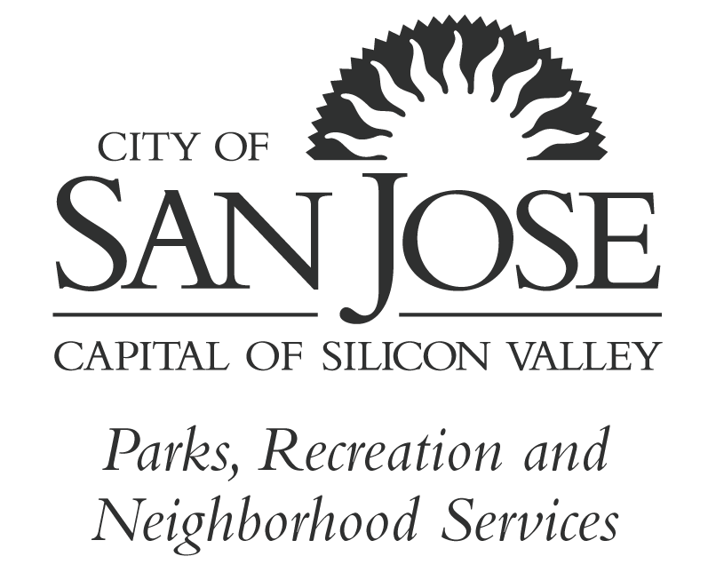
City of San José
Youth Commission

District 1 – Deepankar Joshi Katherine Ho – District 2
District 3 – Maren Bick-Maurischat Lydia Ma – District 4
District 5 – Elizabeth Plancarte Chris Zazueta – District 6
District 7 – Julia Nguyen Anooshree Sengupta – District 8
District 9 – Aruni Areti Samuel Hirst – District 10
Citywide – Sarah Dang
DRAFT MINUTES
March 26, 2018

6:30p.m. – 8:30 p.m. San Jose City Hall
Council Chambers
200 E. Santa Clara St.
San Jose, Ca 95113

I. Call to order and Order of the Day
- Meeting was called to order at 6:34 p.m.
- Commissioners absent: Deepankar Joshi, Elizabeth Plancarte, and Julia Nguyen
- Recognition Awards to members of the D4 Youth Advisory Council for participation in the annual D4 2018 AIM Event: Amy Hua, Ben Vo, Andrew Huynh, PJ Fuentes, Lisa Chau, Evy Huang

II. Public Record
- AB 2601 (Weber): The California Healthy Youth Act in Charter Schools
Motion to table issue to discuss/study next YC meeting made by Commissioner Bick-Maurischat 2: Commissioner Zazueta
- Flier: Youth Commission convening: April 28, 2018 in San Mateo. SJ Youth Commission encouraged to attend. Planning to attend: Commissioner Bick-Maurischat, all other Commissioners must notify Ms. Ramirez by March 28th.

III. Public Comment (Members of the Public are invited to speak on any item that does not appear on today’s Agenda and that is within the subject matter jurisdiction of the Commission. Meeting attendees are usually given two (2) minutes to speak on any discussion item and/or during open forum; the time limit is in the discretion of the Chair of the meeting and may be limited when appropriate. Speakers using a translator will be given twice the time allotted to ensure non-English speakers receive the same opportunity to directly address the Committee, Board or Commission.)
No Public Comment

Youth Commission Meeting Minutes
Page 2
March 26, 2018
IV. Consent Calendar
- February 26, 2018 Monthly Commission Minutes
Motion made by Commissioner Dang to approve as written, Seconded by Commissioner Bick-Maurischat
- Attendance Report
Motion made by Commissioner Dang to approve with correction, Seconded by Commissioner Bick-Maurischat
V. Reports
A. Mayor’s Office, Policy Advisor Paul Pereira
- March Budget message: San Jose Works program returning this summer;
- Beautify San Jose was renewed for another year
- Great American Litter Pick up: April 21, 2018
- Mayor’s Challenge coming back for those schools with the top participation
B. Council Liaison report, Council Assistant Frank Ponciano
- March Budget Message: direction has been given for the City Council to develop a Bond Measure for the November Ballot for Capital Projects (such as road repairs) for 300Million dollars
C. San Jose Library, Senior Librarian Lizzie Nolan – No report
D. Parks, Recreation and Neighborhood, PRNS Staff – No report
E. Youth Commission Chair Report – Last Friday (3/23/2018) YC Event: Three C’s Panel – Chair felt it was a success based on audience feedback; concern with meeting goals from Workplan; will be monitoring activities in the future as it relates to the goals set forth in Workplan.
F. Commission Staff Report -
- Youth Commission Application for the 2018/19-year deadline is 4/2/2018@ 5pm
- City of Homestead, Florida Youth Advisory Council visiting 3/28 @ 4pm in City Manager’s Conference Room T-1734
- “A Couch is Not a Home” PSA from Crea TV: Commissioners Bick -Maurischat & Joshi helped produced
- Commissioner Ma will be featured in Bay Area Parent Magazine for her leadership and involvement in the Community.
G. Commissioners Report by District
a. D1 Commissioner Joshi – absent
b. D2 Commissioner Ho – YAC is working on District project
c. D3 Commissioner Bick-Maurischat – YAC is working on District project
d. D4 Commissioner Ma- YAC working on Mural Project
e. D5 Commissioner Plancarte – absent
f. D6 Commissioner Zazueta – Last YAC meeting cancelled
g. D 7 Commissioner Nguyen – absent
h. D8 Commissioner Sangupta – YAC working on upcoming Movie Event 4/13
i. D 9 Commissioner Areti – YAC working on 2-events upcoming
j. D10 Commissioner Hirst – YAC working on Emergency Preparedness Project
k. D-CW Commissioner Dang – Working on YC Budget Recommendation documents; missing Transportation input

Youth Commission Meeting Minutes
Page 3
March 26, 2018
IV. Consent Calendar
- February 26, 2018 Monthly Commission Minutes
Motion made by Commissioner Dang to approve as written, Seconded by Commissioner Bick-Maurischat
- Attendance Report
Motion made by Commissioner Dang to approve with correction, Seconded by Commissioner Bick-Maurischat
V. Reports
A. Mayor’s Office, Policy Advisor Paul Pereira
- March Budget message: San Jose Works program returning this summer;
- Beautify San Jose was renewed for another year
- Great American Litter Pick up: April 21, 2018
- Mayor’s Challenge coming back for those schools with the top participation
B. Council Liaison report, Council Assistant Frank Ponciano
- March Budget Message: direction has been given for the City Council to develop a Bond Measure for the November Ballot for Capital Projects (such as road repairs) for 300Million dollars
C. San Jose Library, Senior Librarian Lizzie Nolan – No report
D. Parks, Recreation and Neighborhood, PRNS Staff – No report
E. Youth Commission Chair Report – Last Friday (3/23/2018) YC Event: Three C’s Panel – Chair felt it was a success based on audience feedback; concern with meeting goals from Workplan; will be monitoring activities in the future as it relates to the goals set forth in Workplan.
F. Commission Staff Report -
- Youth Commission Application for the 2018/19-year deadline is 4/2/2018@ 5pm
- City of Homestead, Florida Youth Advisory Council visiting 3/28 @ 4pm in City Manager’s Conference Room T-1734
- “A Couch is Not a Home” PSA from Crea TV: Commissioners Bick -Maurischat & Joshi helped produced
- Commissioner Ma will be featured in Bay Area Parent Magazine for her leadership and involvement in the Community.
G. Commissioners Report by District
a. D1 Commissioner Joshi – absent
b. D2 Commissioner Ho – YAC is working on District project
c. D3 Commissioner Bick-Maurischat – YAC is working on District project
d. D4 Commissioner Ma- YAC working on Mural Project
e. D5 Commissioner Plancarte – absent
f. D6 Commissioner Zazueta – Last YAC meeting cancelled
g. D 7 Commissioner Nguyen – absent
h. D8 Commissioner Sangupta – YAC working on upcoming Movie Event 4/13
i. D 9 Commissioner Areti – YAC working on 2-events upcoming
j. D10 Commissioner Hirst – YAC working on Emergency Preparedness Project
k. D-CW Commissioner Dang – Working on YC Budget Recommendation documents; missing Transportation input

Youth Commission Meeting Minutes
Page 4
March 26, 2018
VI. Old Business – review only/ no action
- Commission heard from Silicon Reading Partners to request for summer participation
- Commissioner Bick-Maurischat spoke on and participated in the March for Our Lives Event
- CW Commissioner Dang presented Annual CW Youth Project proposal
- Commissioner Bick-Maurischat presented D3 project proposal for Commission review
- Commissioner Sengupta presented Teen Dating Violence Awareness letter for approval

VII. New Business
- CW Commissioner Dang will present the Youth Commission Budget Recommendation for approval: Commissioner Dang motioned for the YC to approve the YC Budget Recommendations with revisions (spelling corrections & addition of Transportation piece) and seconded by Commissioner Areti.
- Commissioners discussed the Youth Commission Panel Event evaluations. No action/ discussion only
- Commissioners discussed hosting the Youth Council from Homestead Florida on 3/28/18 from 4-6 on the 17th floor; City Manager’s Conference room. YC will take visiting youth on an abbreviated tour of City Hall, then return to the 17th floor where they wioll exchange dialog and share dinner.
VIII. Meeting Schedule and Agenda Items:
The next regular meeting will be Monday April 23, 2018 at 6:30pm in the City Council Chambers of the City Hall Wing Building.

XI. Adjournment Meeting was adjourned at 7:52pm

The City of San José is committed to open and honest government and strives to consistently meet the community’s expectations by providing excellent service, in a positive and timely manner, and in the full view of the public.

You may speak to the Commission about any discussion item that is on the agenda, and you may also speak during Public Comments on items that are not on the agenda and are within the subject matter jurisdiction of the Commission. Please be advised that, by law, the Commission is unable to discuss or take action on issues presented during Public Comments. Pursuant to Government Code Section 54954.2, no matter shall be acted upon by the Commission unless listed on the agenda, which has been posted not less than 72 hours prior to meeting.
Agendas, Staff Reports and some associated documents for the Commission items may be viewed on the Internet at
All public records relating to an open session item on this agenda, which are not exempt from disclosure pursuant to the California Public Records Act, that are distributed to a majority of the legislative body will be available for public inspection at the Office of the City Clerk, 200 East Santa Clara Street, 14th Floor, San José, California 95113, at the same time that the public records are distributed or made available to the legislative body. Any draft resolutions or other items posted on the Internet site or distributed in advance of the commission meeting may not be the final documents approved by the commission. Contact the Office of the City Clerk for the final document.
On occasion the Commission may consider agenda items out of order.
The Youth Commission meets every 4th Monay of each month at 6:30pm, with special meetings as necessary. If you have any questions, please direct them to the Commission staff. Thank you for taking the time to attend today’s meeting. We look forward to seeing you at future meetings.

To request an accommodation or alternative format under the Americans with Disabilities Act for City-sponsored meetings, events or printed materials, please call (408) 535-1260 as soon as possible, but at least three business days before the meeting.
Please direct correspondence and questions to:
City of San José
Attn: Betty Ramirez
200 East Santa Clara Street
San José, California 95113
Tel: (408) 535-5559
Email: Betty.ramirez@sanjoseca.gov

