Educational Facilities

E

6 or more children

State and Local Regulations

San Jose Fire Department

Bureau of Fire Prevention

200 E Santa Clara Street

San Jose, CA 95113-1905

(408) 535-7750

(Please call for an appointment when you are ready for inspection)

INSPECTION FEES

**Note:**

These requirements are from 2022 California Fire Code, 2022 California Building Code, and Local Codes. They **do not include or address every possible code or situation.**



City of San Jose Residents Only

The State Fire Marshal has set guidelines to promote fire and life safety standards for all educational facilities. These standards apply to both commercial and residential facilities. This self-guided packet is designed to assist you prepare your facility for your fire clearance inspection. We encourage you to read this booklet and call a Fire Inspector if you have any questions.

For an 850 fire clearance inspection a Fire Inspector will schedule an appointment with you during regular business hours.

For a state mandated annual school inspection a Fire Inspector will conduct an unscheduled fire and life safety inspection during regular business hours.

SAN JOSE FIRE DEPARTMENT INSPECTION FEE SCHEDULE

Inspection Type Fees_____________________________

Final Inspection

Public/Charter School Annual Inspection No Charge

Private School Annual Initial Inspection Included in Annual Permit Fee

Re-Inspection Hourly Fee

PAYMENT

Upon completion of inspection the city will send a bill to the applicant. Bills will be mailed to the address of the facility; unless otherwise requested.

**STANDARDS FOR EDUCATIONAL FACILITIES**

**(E Occupancies for six or greater children)**

For use by Unidocs member agencies or where approved by your local jurisdiction.

This document is intended to help all prospective state licensed educational facilities comply with the minimum requirements necessary for local fire and life safety inspection and initial clearance. This occupancy group (E) may include private day care on a public school campus, private school in a commercial or residential structure or before and/or after school care in any facility.

This document can also be used in preparation of an educational facility’s state mandated annual fire and life safety inspection.

This document does not address every possible code or situation. Please contact your local fire jurisdiction for more information. Regulations regarding educational facilities are found in the 2022 edition of the California Building Code (CBC), the 2022 California Fire Code (CFC), Title 19 of the California Code of Regulations (CCR) and the California Health & Safety Code.

1. **FIRE CLEARANCE PROCESS FOR STATE LICENSING**
2. Pre-Inspection (form 9092) – This form is provided by the State licensing authority during the initial application phase. It is strongly encouraged that applicants utilize the pre-inspection process as it provides consultative information from the local fire jurisdiction regarding the appropriateness of a property to become a residential care facility. Please contact the local fire jurisdiction for scheduling and fee information.
3. Fire Clearance Request (form 850) – This form is sent to the local fire jurisdiction by the State licensing authority. The local fire jurisdiction will contact the applicant to schedule an inspection. Once all items have been addressed, the 850 form will be mailed to the State licensing authority by the local fire jurisdiction.
4. Additional Submittals – During the course of inspections, items may be identified that require formal submittals to the building department. These typically include interior ramp installation, building modification, and unpermitted construction. Depending on the specific project, it may be necessary to provide information beyond what is described in this guidance document including architectural drawings and building permits.
5. Certificate of Occupancy – Provide the Certificate of Occupancy for the building. If the building was not built to be a place of education (E) the facility will have to apply for a Change of Occupancy to either an E or a mixed use occupancy.
6. **GENERAL CALIFORNIA FIRE CODE REQUIREMENTS**
7. Address numbers shall be clearly posted on the facility and visible from the street. Numbers shall contrast with their background and shall be sufficiently illuminated for viewing at night. Illumination may be either internal or external. *[2022 CFC 505.1]*
8. Artwork - Artwork and teaching materials shall not exceed 20 percent of the wall area in the building that is NOT protected throughout by an approved automatic sprinkler system, 50% of area with an approved sprinkler system.
9. Emergency Evacuation Plan – An emergency evacuation plan shall be in place and reviewed by all employees. [2022 CFC 404.3, 404.4, 404.1]
10. Emergency Vehicle Access – All fire access roads must be maintained free of obstacles. [2022 CFC 503.1, 503.1.2]
11. Evacuation Maps – An evacuation map shall be posted in every classroom and at the main entrance/exit. [2022 CFC 403.4.1.1 #3]
12. Exits - There shall be a minimum of two exits from the dwelling. Exits shall be 36 inches wide and 6 feet, 8 inches tall and provide a 32-inch clear opening. Exit doors shall be remote from each other, and shall not pass through kitchens, garages, storerooms or closets and shall not pass through more than one intervening room. *[2022 CFC & CBC 1006.2 and Appendix 435.8.2 and 435.8.3.2]*
    * Each classroom shall have at least 2 exits
    * All exits shall open in the path of egress and be equipped with panic hardware or single action handles.
    * This includes baby gates and external gates.
13. Exit Illumination – Exit signs shall be illuminated. [2022 CFC 1013.5]
14. Fire Alarms, Smoke and Carbon Monoxide alarms and detectors
    * A centrally monitored fire alarm is required. It must have voice and visual alarms (strobes). This will also include at least one manual pull station located in an easily accessible location. [2022 CFC 907.2.3]
    * The fire alarm panel is required to have an annual inspection by a UL certified technician. [2022 CFC 907.2.32]
    * Carbon monoxide alarms shall be installed in all existing group R occupancies. The carbon monoxide alarms shall be listed as complying with UL 2034 and be installed and maintained in accordance with NFPA 720 and the manufacturer’s instructions. *[2022 CBC 420.5]*
15. Fire Drills – A fire drill shall be conducted per the California Fire Code. The frequency is based on the age of the children. [2022 CFC 403.4.1 – 404.4.4]
16. Fire extinguisher – At least one 2A:10B:C rated fire extinguisher shall be mounted in a visible and accessible location with the top of the extinguisher no higher than 5 feet. The maximum travel distance to an extinguisher shall not be more than 75 feet. Fire extinguishers shall be serviced annually with a service tag attached. *[2022 CFC 906.1]*
    * There shall be a fire extinguisher located in each room regardless if it is within 75’ if there is a closeable door between the two rooms.
17. Flammable liquids - Storage and use of more than 5 gallons of flammable liquids requires a permit. Such liquids may not be stored inside of the residence*. [2022 CFC 105.5.18]*
18. Garages – If a garage is attached to a school in a residential structure, the door between the residence and the garage shall be maintained to be self-closing and self-latching. The door shall be fire rated or a minimum 13/8 inch thick solid wood door. The garage shall not be used as anything other than a garage unless it is permitted for occupancy. There shall be no additional openings from the garage into any portion of the residence. Maintain the garage in a neat, orderly fashion with minimal combustible storage. Clearance between the water heater and any combustible material shall be maintained in accordance with the manufacturer’s specifications and the heater’s listing. Typically, 18 inches is the minimum clearance required*. [2022 CBC 406.3.2.1]*
19. Heating appliances - Every heating appliance which does not have protective features incorporated into the design shall be provided with guards that will provide protection against the ignition of clothing and combustible materials. *[2022 CFC 605.6]*
20. Permits approved by the Building Official shall be presented to the inspector for all additions, remodels or conversions. [2022 CFC 105.1]
21. Second Story access shall be allowed as long as the following criteria is met: [2022 CFC 903.2.3]
    * Monitored Fire Alarm system
    * Automatic Sprinkler system throughout the building if the building is > 12,000 sq. feet
    * Means of Egress from the second floor on the exterior of the building?????
22. ADDITIONAL REQUIREMENTS FOR EXISTING STRUCTURES AND SYSTEMS
23. All existing suppression systems must be maintained [TITLE 19, DIV. 1 CH. 5]
    1. Sprinkler systems must be current on their 5-yr flow test [NFPA 13.2.1]
       1. Sticker shall be placed on main riser.
    2. Fire alarm panels or manual pull stations must be current on the annual inspection. [2022 CFC 907.2.3]
       1. Include the code stating that documents must be kept on site.
    3. Fixed extinguishing systems (Ansul) must be current on the semi-annual inspection. [2022 CFC 904.4-904.12]
       1. Tag shall be affixed on or next to the pull handle.
    4. Kitchen hood and ducts must be current on the steam cleaning inspection. [2022 CFC 606.3.3.1]
       1. Sticker shall be placed on the hood.

Panic Hardware Single Action Lever Locks

A door-locking assembly that can be released quickly by - Press down on the lever

[pressure](http://www.dictionaryofconstruction.com/definition/pressure.html) on a [horizontal](http://www.dictionaryofconstruction.com/definition/horizontal.html) [bar](http://www.dictionaryofconstruction.com/definition/bar.html). Panic hardware is required - Deadbolt and lever latch retract simultaneously

by [building codes](http://www.dictionaryofconstruction.com/definition/building-codes.html) on certain [exits](http://www.dictionaryofconstruction.com/definition/exit.html). [2022 CFC 1010.2.4]

2022 CFC 1010.2.9]

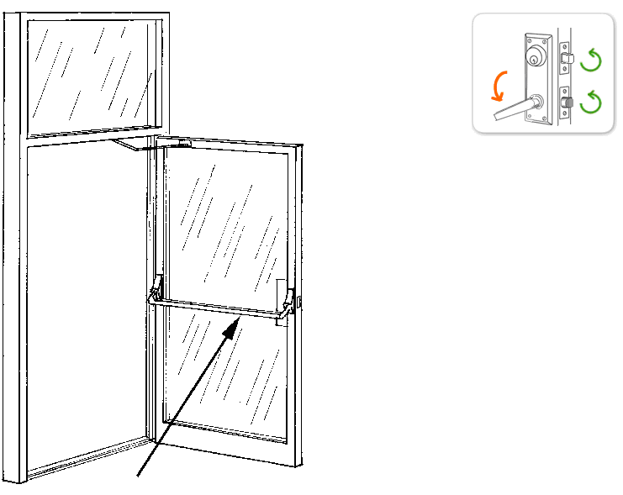

**Door Swing in Direction of Egress**

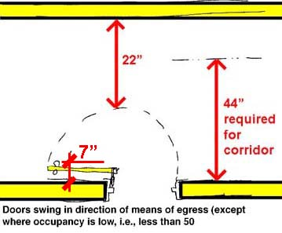

Fire Extinguishers

All fire extinguishers shall be mounted between 3 and 5 feet above the floor. The bottom of the extinguisher must have a 4 inch clearance from the floor.

**Fire extinguishers must be visible and accessible.**

*[2022 CFC 906.5, 906.9.1, 906.9.2, CCR Title 19, Div. 1, §567.6]*

**Provide a fire extin**guisher, rated at least 2A:10B:C, and be sure to install it correctly. Your fire extinguisher needs to be serviced annually, and after discharge, by a licensed technician and must have a State Fire Marshal Service Tag.

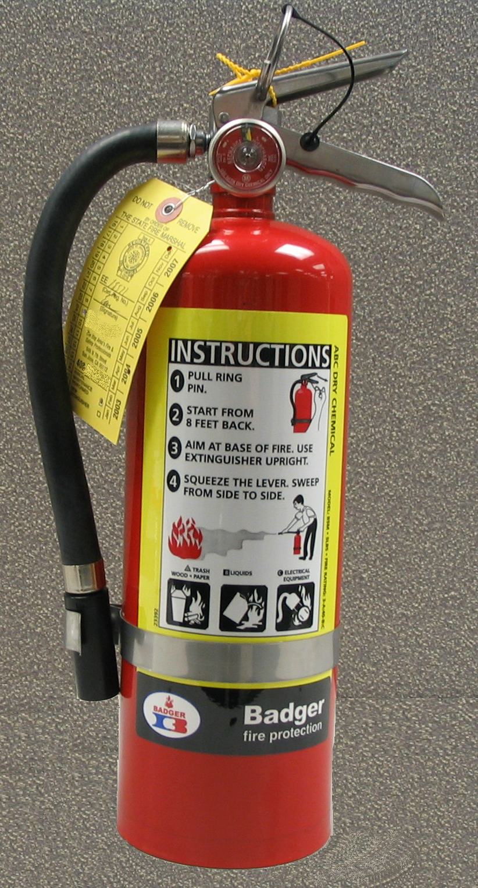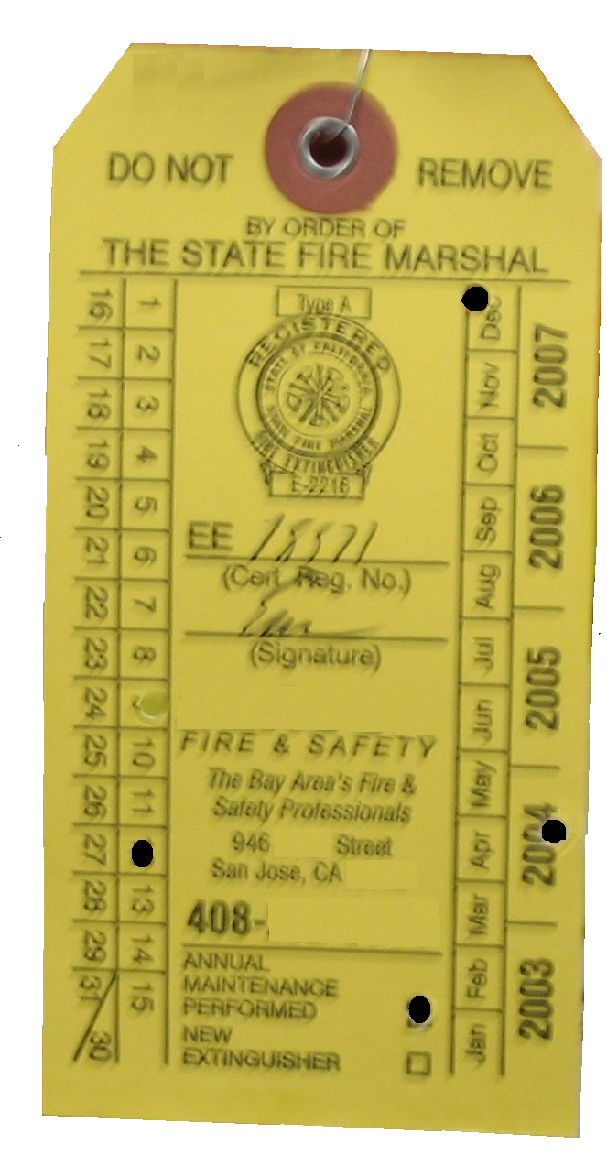

State Fire Marshal Service Tag:

Punched date indicates date of service not expiration date. The service is good for one year from punched date. A new extinguisher is good for one year from purchase date (must maintain the store receipt.)

### The Fire Extinguisher Rating/Classification,

such as 2A:10B:C, may be found near the UL label

2

