Residential Care Facilities
R3.1/ R2
For six or less clients

State and Local Regulations

San Jose Fire Department
Bureau of Fire Prevention
200 E Santa Clara Street
San Jose, CA 95113-1905
(408) 535-7750

(Please call for an appointment when you are ready for inspection)
Note:
These requirements are from 2022 California Fire Code, 2022 California Building Code, and Local Codes. They do not include or address every possible code or situation.
INSPECTION FEES

City of San Jose Residents Only

The State Fire Marshal has set guidelines to promote fire and life safety standards for the clients in residential care homes. This self-guided booklet is designed to assist you in preparing your home for your fire clearance inspection. We encourage you to read this booklet and call a Fire Inspector if you have any questions.

A representative of the Fire Department will schedule an appointment with you during regular business hours.

SAN JOSE FIRE DEPARTMENT INSPECTION FEE SCHEDULE

Inspection Type Fees________

Pre Inspection Minimum charge: 1.5 hour

Final Inspection No Charge

PAYMENT

Upon completion of inspection the city will send a bill to the applicant. Bills will be mailed to the address of the facility; unless otherwise requested.

STANDARDS FOR RESIDENTIAL CARE FACILITIES

(R3.1 Occupancies for six or fewer clients)

For use by Unidocs member agencies or where approved by your local jurisdiction.

This document is intended to help residential care facility owners/operators comply with minimum requirements necessary for local fire jurisdiction review and approval of licensed care facilities housing six (6) or fewer clients in single-family residences. This occupancy group may include facilities licensed by a governmental agency for residentially based 24-hour care providing accommodations for six or fewer clients of any age. Clients may be classified as ambulatory, non-ambulatory, or bedridden.

This document does not address every possible code or situation. Please contact your local fire jurisdiction for more information. Regulations regarding residential care facilities are found in the 2022 edition of the California Building Code (CBC), the 2022 California Fire Code (CFC), Title 19 of the California Code of Regulations (CCR) and the California Health & Safety Code.

- FIRE CLEARANCE PROCESS

- Pre-Inspection (form 9092) – This form is provided by the State licensing authority during the initial application phase. It is strongly encouraged that applicants utilize the pre-inspection process as it provides consultative information from the local fire jurisdiction regarding the appropriateness of a property to become a residential care facility. Please contact the local fire jurisdiction for scheduling and fee information.

- Fire Clearance Request (form 850) – This form is sent to the local fire jurisdiction by the State licensing authority. The local fire jurisdiction will contact the applicant to schedule an inspection. Once all items have been addressed, the 850 form will be mailed to the State licensing authority by the local fire jurisdiction.

- Additional Submittals – During the course of inspections, items may be identified that require formal submittals to the building department. These typically include interior ramp installation, building modification, and unpermitted construction. Depending on the specific project, it may be necessary to provide information beyond what is described in this guidance document including architectural drawings and building permits.

- GENERAL REQUIREMENTS

- Address numbers shall be clearly posted on the house and visible from the street. Numbers shall contrast with their background and shall be sufficiently illuminated for viewing at night. Illumination may be either internal or external. [2022 CFC 505.1]

- Garages – If a garage is attached to the residence, the door between the residence and the garage shall be maintained to be self-closing and self-latching. The door shall be fire rated or a minimum 1³/₈ inch thick solid wood door. The garage shall not be used for sleeping purposes. There shall be no additional openings from the garage into any portion of the residence. Maintain the garage in a neat, orderly fashion with minimal combustible storage. Clearance between the water heater and any combustible material shall be maintained in accordance with the manufacturer’s specifications and the heater’s listing. Typically, 18 inches is the minimum clearance required. [2022 CBC 406.3.2.1]

- Stairway Doors – A non-rated door may be used to provide the required floor separation to prevent smoke migration between floors. The door shall have the equivalent construction of ½ inch gypsum wallboard on one side of the wall studs (e.g., 20 minute rated assembly or 1³/₈ inch solid core door). The door shall be tightfitting, positive latching, smoke gasketed, and automatic closing upon activation of the smoke detector. This requirement will be waived if the building is provided with fire sprinklers or has at least one exterior exit from each floor occupied by clients. [2022 CFC 435.8.7]

- Exits - There shall be a minimum of two exits from the dwelling. Exits shall be 36 inches wide and 6 feet, 8 inches tall and provide a 32-inch clear opening. Exit doors shall be remote from each other, and shall not pass through kitchens, garages, storerooms or closets and shall not pass through more than one intervening room. [2022 CFC & CBC 1006.2 and Appendix 435.8.2 and 435.8.3.2]

- No bed, chair, equipment, storage materials or any other item shall be placed in any manner that would block or obstruct the required width of an exit. This shall include the exterior sidewalks leading from the exits to the public way. [Title 19, Div 1, 3.11(a-d)]
- A floor or landing shall be provided on each side of every exit door. The floor or landing shall not be more than ½ inch lower than the threshold of the doorway. [CBC 1008.1.7]
  - The exterior floor or landing shall have a minimum width of 44 inches and be at least as wide as the opening.

- Ramps - Homes may require ramps. If the exterior landing has more than ½ inch step down, a ramp shall be provided. The slope of the ramp shall not be steeper than 1 inch vertical to 12 inches horizontal with a minimum clearance width of 36 inches. As an example, a 6-inch drop from a landing would require a 6-foot long ramp. Ramps shall have a non-skid surface. [2022 CFC 1012, California Residential Code 311.8]

- Handrails shall be provided if ramps have more than a 6 inch rise. The top of the handrail shall not be less than 34 and not more than 38 inches in height. [2022 CBC 1012.8]

- Fire extinguisher - One 2A:10B:C rated fire extinguisher shall be mounted in a visible and accessible location with the top of the extinguisher no higher than 5 feet. The maximum travel distance to an extinguisher shall not be more than 75 feet. Fire extinguishers shall be serviced annually with a service tag attached. [2022 CFC 906.1]

- Heating appliances - Every heating appliance which does not have protective features incorporated into the design shall be provided with guards that will provide protection against the ignition of clothing and combustible materials. [2022 CFC 605.6]

- Flammable liquids - Storage and use of more than 5 gallons of flammable liquids requires a permit. Such liquids may not be stored inside of the residence. [2022 CFC 105.5.18]

- Permits approved by the Building Official shall be presented to the inspector for all additions, remodels or conversions.

- Smoke and Carbon Monoxide alarms and detectors

- A smoke alarm shall be installed in each sleeping room and at a point centrally located in the hallway or area giving access to the sleeping areas. Additional detectors may be required for vaulted ceilings adjacent to the hallway. Detectors shall sound an alarm audible in all sleeping areas of the unit in which they are located. [CBC 907.2.11.2]
- Smoke alarms shall be interconnected in such a manner that the activation of one alarm will activate all of the alarms. Listed wireless alarms are allowed. [2022 CBC 907.2.11.3]
- In newly classified group R3.1 occupancies smoke alarms shall receive their primary power from the building wiring where such wiring is served from a commercial source and shall be equipped with a battery backup. [2022 CBC 907.2.11.6]
- Carbon monoxide alarms shall be installed in all existing group R occupancies. The carbon monoxide alarms shall be listed as complying with UL 2034 and be installed and maintained in accordance with NFPA 720 and the manufacturer’s instructions. [2022 CBC 420.5]

SEE EXAMPLE ON PAGE 6 FOR DETECTOR PLACEMENT

- Sleeping rooms used by non-ambulatory clients shall have access to at least one required exit which conforms to one of the following: [2022 CFC & CBC Appendix 425.8.3.2]

- Exits through a corridor/hallway or area and into a sleeping room (in the immediate area), which has an exit directly to the exterior. Bedroom doors used as exits shall have exit signs and shall not be provided with a lock or latch preventing egress. The hallway shall be separated from the common areas by a solid wood door not less than 1 ³/₈ inch in thickness, maintained self-closing or shall be automatic closing by actuation of a smoke detector.
- Through a corridor/hallway serving the sleeping area, which exits directly to the exterior. The hallway shall be separated from the common areas by a solid wood door not less than 1 ³/₈ inch in thickness, maintained self-closing or shall be automatic closing by actuation of a smoke detector.
- Direct from the bedroom to the exterior.
- Exit through an adjoining bedroom that exits to the exterior. (No private locks on bedroom doors are allowed, if exiting through bedroom).

SEE EXAMPLE DIAGRAMS ON PAGES 9-12

- Bedridden Fire Clearance : Additional Requirements:

- In all facilities housing a bedridden client, smoke alarms shall receive their primary power from the building wiring and be equipped with a battery backup. Smoke alarms shall be electrically interconnected so as to cause all smoke alarms to sound a distinctive alarm signal upon actuation of any single smoke alarm. Such alarm signal shall be audible throughout the facility at a minimal level of 15 db above ambient noise level. These devices need not be interconnected to any other fire alarm device, have a control panel, or be electrically supervised or provided with emergency power. [2022 CFC 1103.8.4]

- R3.1 occupancies that are not provided with an approved automatic sprinkler system are only allowed clearance for 1 bedridden client. [2022 CFC 903.2.8]

- Non-sprinklered R3.1 occupancies housing a bedridden client shall have all of the following:
  - Client sleeping room shall have a direct exit to the exterior.
  - Doors to a bedridden client’s sleeping room shall be of a self-closing, positive latching 1 ³/₈ inch solid wood door. Such doors shall be provided with a gasket so installed as to provide a seal where the door meets the jam on both sides and across the top. Doors shall be maintained self-closing or shall be automatic closing by actuation of a smoke detector. [2022 CBC 716.5.9]
  - Group R3.1 occupancies housing a bedridden client shall not have a night latch, dead bolt, security chain or any similar locking device installed on any interior door leading from a bedridden client’s sleeping room to any interior area such as a corridor, hallway and or general use areas of the residence in accordance with chapter 10.
  - The exterior exit door to a bedridden client’s sleeping room shall be operable from both the interior and exterior of the residence.
  - Every required exit doorway from a bedridden client sleeping room shall be of a size as to permit the installation of a door not less than 3 feet in width and not less than 6 feet 8 inches in height. When installed in exit doorways, exit doors shall be capable of opening at least 90 degrees and shall be so mounted that the clear width of the exit way is not less than 32 inches.
  - Note: a sliding glass door can be used as an exterior exit doorway as long as it is operable from the inside and outside and the clear width of the exit way is not less than 32 inches.
    - [2022 CFC 435.8.3.3]

- In R3.1 occupancies housing a bedridden client, the sleeping room shall not be located above or below the first floor. [2022 CFC 435.3.2]

- Exception: Clients who become bedridden as a result of a temporary illness as defined in Health and Safety Code, Sections 1566.45, 1568.0832, and 1569.72. A temporary illness is an illness which persists for 14 days or less. A bedridden client may be retained in excess of the 14 days upon approval by the Department of Social Services and may continue to be housed on any story in a Group R 3.1 occupancy classified as a licensed residential facility. [2022 CFC 435.3.2]

Safety
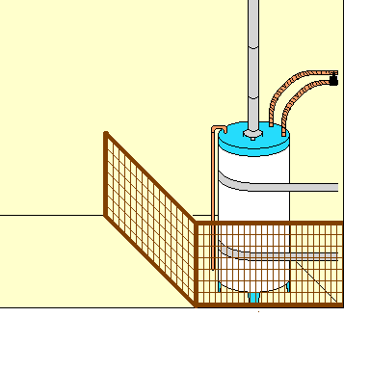
Gas Appliances:
Enclose gas fired water heaters and furnaces to protect against ignition of clothing and other combustible materials.
[2022 CFC 605.6]
Back Yard Gate:
Side gates that are part of the exit path out to a public way must meet exit door requirements. An example of a simple, single action set-up would be wire/string with a handle at the client’s level that is attached to the normal gate latch. If the gate opens inward a handle at clients’ level is also required.
[2022 CFC (appendix) 435.8.8]
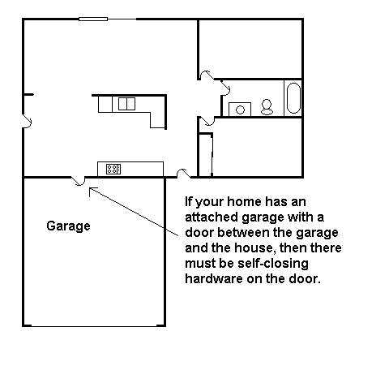
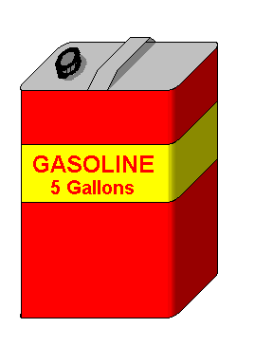
Flammable Liquids:
Storage and use of more than 5 gallons of gasoline or other flammable liquid requires a permit.
[2022 CFC 105.5.1.8]

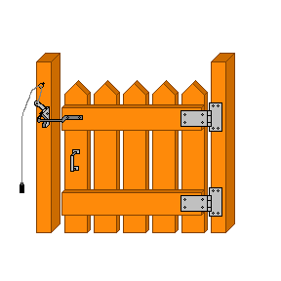
[2022 CBC 406.3.2.1]
Smoke Detector Placement
Provide a residential type smoke detector
approved by the State Fire Marshal
for all areas.
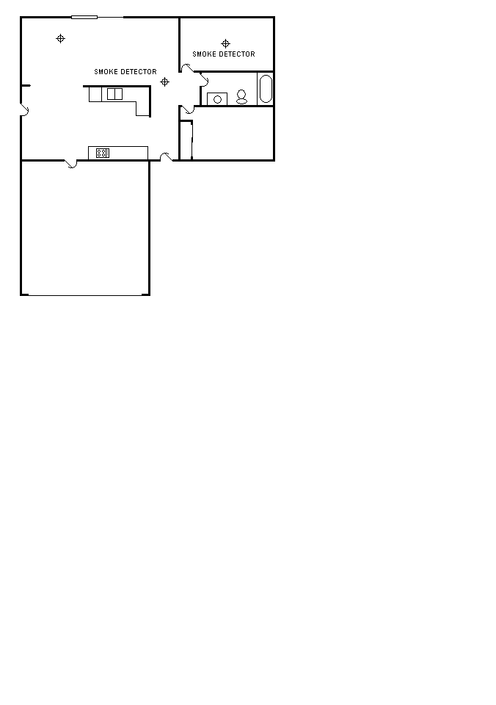
Inside and directly outside all bedrooms, sleeping rooms and rooms occupied by clients there must be a smoke detector.

Smoke detectors are not required in kitchens and bathrooms.

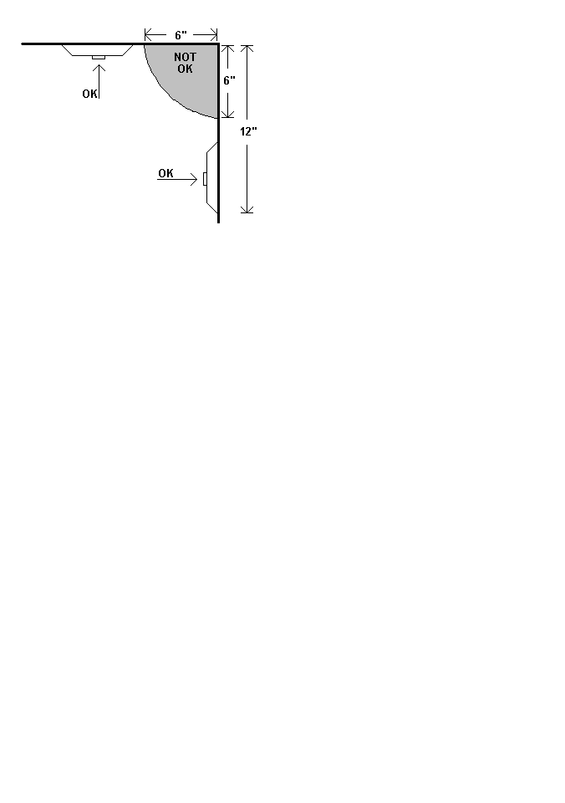.
The smoke detector should be mounted on the ceiling. Do not mount closer than 6 inches to the corner of the ceiling and the wall. In special cases where the smoke detector must be mounted on the wall, do not mount closer than 6 inches to the ceiling or further than 12 inches away.
[2022 CFC 907.2.3.6.1]

ceiling
wall

Fire Extinguishers
All fire extinguishers shall be mounted between 3 and 5 feet above the floor. The bottom of the extinguisher must have a 4 inch clearance from the floor.
Fire extinguishers must be visible and accessible.
[2022 CFC 906.5, 906.9.1, 906.9.1.2, CCR Title 19, Div. 1, §567.6]

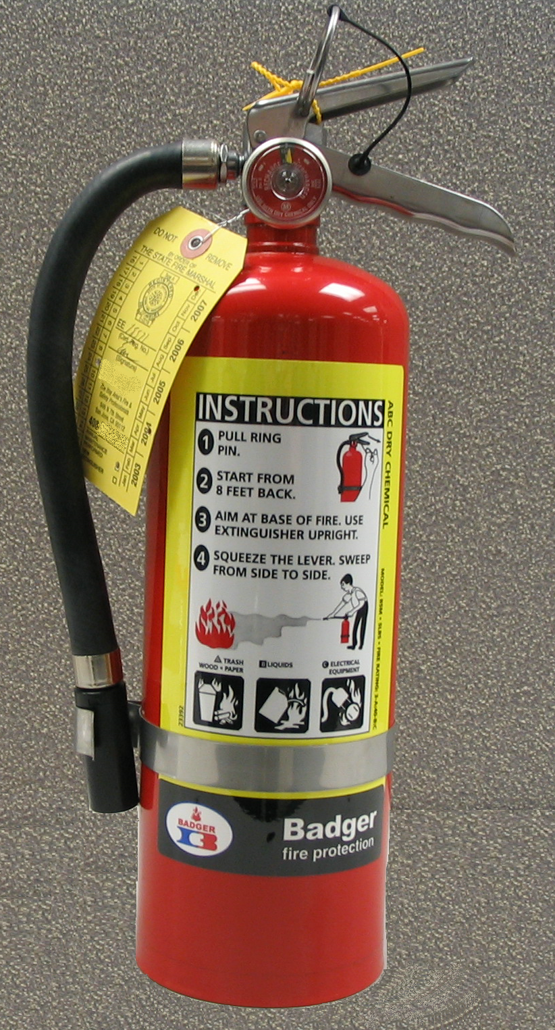

Provide a fire extinguisher, rated at least 2A:10B:C, and be sure to install it correctly. Your fire extinguisher needs to be serviced annually, and after discharge, by a licensed technician and must have a State Fire Marshal Service Tag.

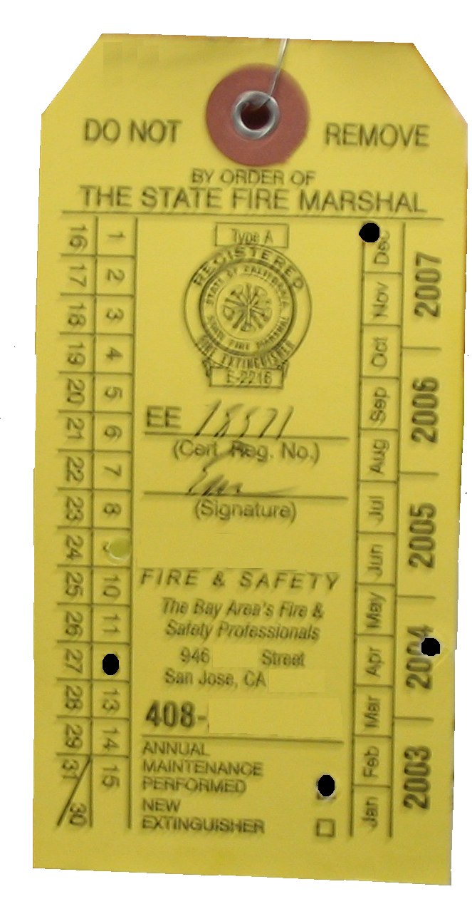

State Fire Marshal Service Tag:

Punched date indicates date of service not expiration date. The service is good for one year from punched date. A new extinguisher is good for one year from purchase date (must maintain the store receipt.)

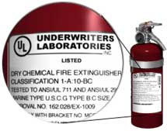

The Fire Extinguisher Rating/Classification,
such as 2A:10B:C, may be found near the UL label
2
Fire Alarm Strobe and Manual Pull Stations

- Notification appliance alarms are no longer required in most newly classified R3.1 facilities, yet those already in existence must be maintained. [2022 CFC section 907.8.4]

- Protective Social Care facilities which house persons who are hearing impaired, shall be provided with notification appliances for the hearing impaired installed in accordance with NFPA 72 and which shall activate upon initiation of the fire alarm system or the smoke alarms. [2022 CFC section 907.5.2.3.4]

- Protective social care facility defined: A facility housing persons, who are referred, placed or caused to be placed in the facility, by any governmental agency and for whom the services, or portion thereof, are paid for by any governmental agency. These occupancies shall include, but are not limited to, those commonly referred to as “assisted living facilities,” “social rehabilitation facilities,” “certified family care homes,” “out-of-home placement facilities,” and “half-way houses.” [2022 CFC chapter 2 definitions]
Two Exits Required

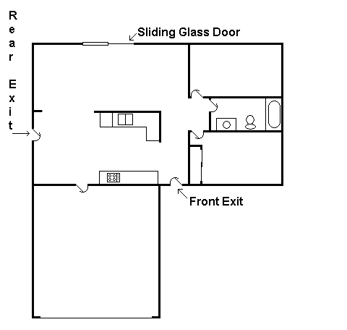

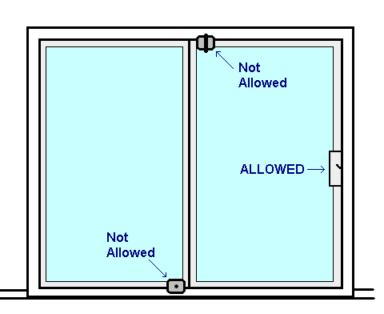
A sliding glass door may be used for one of the two exits.
[2022 CFC 1006.2.2.7]
On Sliding Doors only the manufacturers locking hardware is allowed. No additional locks may be added.

Non-Ambulatory Egress Arrangements
- Sleeping rooms used by non-ambulatory clients shall have access to at least one required exit which conforms to one of the following: [2022 CFC & CBC Appendix 435.8.3.2]

- Exits through a corridor/hallway or area and into a sleeping room (in the immediate area), which has an exit directly to the exterior. Bedroom doors used as exits shall have exit signs and shall not be provided with a lock or latch preventing egress. The hallway shall be separated from the common areas by a solid wood door not less than 1 ³/₈ inch in thickness, maintained self-closing or shall be automatic closing by actuation of a smoke detector.

Bathroom
Bathroom
Provider Bedroom
Bedroom
2 non-ambs
Bedroom
2 non-ambs
Bedroom
2 non-ambs
Kitchen
Living Room
Example A:
From Room to Hallway to Room and Out

Bathroom
Bathroom
Provider Bedroom
Bedroom
2 non-ambs
Bedroom
2 non-ambs
Bedroom
2 non-ambs
Kitchen
Living Room
Example B:
From Room to Hallway to Outside
- Through a corridor/hallway serving the sleeping area, which exits directly to the exterior. The hallway shall be separated from the common areas by a solid wood door not less than 1 ³/₈ inch in thickness, maintained self-closing or shall be automatic closing by actuation of a smoke detector.

Bathroom
Bathroom
Provider Bedroom
Bedroom
2 non-ambs
Bedroom
2 non-ambs
Bedroom
2 non-ambs
Kitchen
Living Room
Example C:
Direct Exits to Exterior
- Direct from the bedroom to the exterior.

Bathroom
Bathroom
Provider Bedroom
Bedroom
2 non-ambs
Bedroom
2 non-ambs
Bedroom
2 ambulatory
Kitchen
Living Room
Example D:
From Room to Room to Outside

- Exit through an adjoining bedroom that exits to the exterior. (No private locks on bedroom doors are allowed, if exiting through bedroom).

