Large Family Day Care

State and Local Regulations

San Jose Fire Department

Bureau of Fire Prevention

200 E Santa Clara Street

San Jose, CA 95113-1905

(408) 535-7750

INSPECTION FEES



**Note:**

**These requirements are from 2022 California Building Code and 2022 California Fire Code. They do not include or address every possible code or situation.**

City of San Jose Residents Only

The State Fire Marshal has set guidelines to promote fire and life safety standards for the children in large family day-care homes. The San Jose Fire Department has created this self-guided booklet to assist you in preparing your home for your fire clearance inspection. We encourage you to read this booklet and call a Fire Inspector if you have any questions. Inspection fees must be paid in advance.

A representative of the Fire Department will schedule an appointment with you during regular business hours.

850 INSPECTIONS

Pre-Inspection (Recommended) - An inspector-guided walk through of your facility to check for compliance and to consult on potential code violations. Issues can be corrected and another “pre-inspection” or “final inspection” can be scheduled for a later date. If there are no compliance issues, you may obtain fire clearance, yet pre-inspection fees still apply.

Final Inspection (PASS/FAIL) – A home inspection to grant fire clearance for your facility. A failure results in denial of fire clearance. You will need to reinitiate the application process through DSS.

SAN JOSE FIRE DEPARTMENT INSPECTION FEE SCHEDULE

Inspection type

Pre Inspection Minimum charge: 1.5 hour

Final Inspection No Charge (PASS/FAIL)

PAYMENT

Upon completion of inspection the city will send a bill to the applicant. Mailed to the address of the facility; unless otherwise requested.

Inspection Checklist for

Large Family Day Care Occupancies

(2022 California Fire Code and Building Code)

2022 California Building Code defines a Large Family Day-Care Home as a provider’s own home which is licensed to provide day care for periods less than 24 hours per day for 9-14 persons, including children under the age of 10 years who reside at the home.

1. Address shall be visible and legible from the street. *(2022 CFC 505.1)*
2. All day care rooms should be located on the first floor.

Rooms used for Day care purposes shall not be located above the first floor. (*2022 CBC 1006.2.2.7)*

1. If the basement is used for day care purposes, it must have an exit leading directly to the outside. (*2022 CFC 1006.2.2.7)*
2. Two exits, remote from each other are required. Exit doors must open without a key, special effort or knowledge. A horizontal sliding door may be used as one of the two exits. A side gate must also conform to easy access exiting. (2022 CFC 1006.2.2.7)
3. All day care areas shall have approved smoke detectors mounted on the ceiling in the center of the room. All smoke detectors must be interconnected so that activation of one detector will actuate all. (*2022 CFC 907.2.3.6.1)*
4. Every Large Family Day Care shall be provided with at least one manual device, which shall actuate a fire alarm signal which shall be audible throughout the facility at a minimum level of 15 db above ambient noise. (*2022 CFC 907.2.6.5)*
5. One 2A10BC rated fire extinguisher shall be mounted in a visible and accessible location with the top of the extinguisher no higher than 5 feet. Fire extinguishers shall be serviced annually with a service tag attached. *(2022 CBC § 455.4)*
6. Enclose all gas fired water heaters and furnaces if they are located in day care areas. *(2022 CBC 455.7)*
7. Storage and use of more than 5 gallons of flammable liquids requires a permit. (*2022 CFC 105.5.18 )*
8. A self-closing door (equivalent to a solid core . 1 3/8 inch, 20 min rated) is required between the home and the attached garage. No doorstops are allowed. (*2022 CBC 406.3.2.1 )*
9. Beginning January 2013, all Large Family Day Care homes shall be equipped with a Carbon Monoxide (CO) Alarm. (*2022 CBC 455.2)*
10. Permits approved by the building official shall be presented to the inspector for all additions, remodels or conversions.

SAFETY

Smoke DetectorPlacement

*(2022 CFC 406.3.2.1)*

**Gas Appliances:**

Enclose gas fired water heaters and furnaces in the day care area to keep children from touching or playing with these appliances.

*(2022 CBC 455.7)*

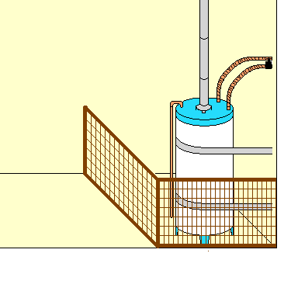

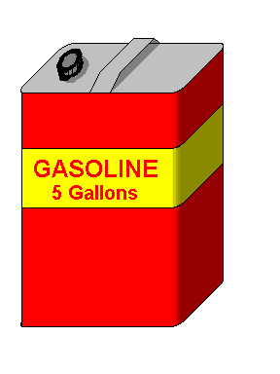

**Flammable liquids:**

Storage and use of more than 5 gallons indoors or 10 gallons outdoors of gasoline or other flammable liquid requires a permit.(*2022 CFC 105.5.18)*

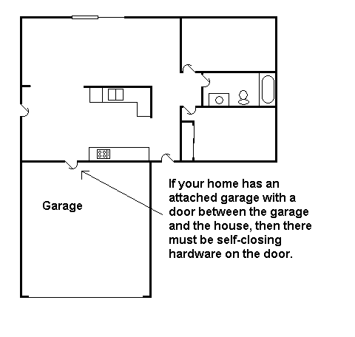

Provide a residential type smoke detector

**approved by the State Fire Marshal**

**for all areas occupied by children**

*(2022 CBC 455.3 and 2022 CFC 907.2.3.9.2)*Fire Alarm Pull Stations

Inside and directly outside all bedrooms, sleeping rooms and rooms occupied by children (i.e. playrooms) there must be a smoke detector.

Smoke detectors are not required in kitchens and bathrooms.

Battery Power OK.

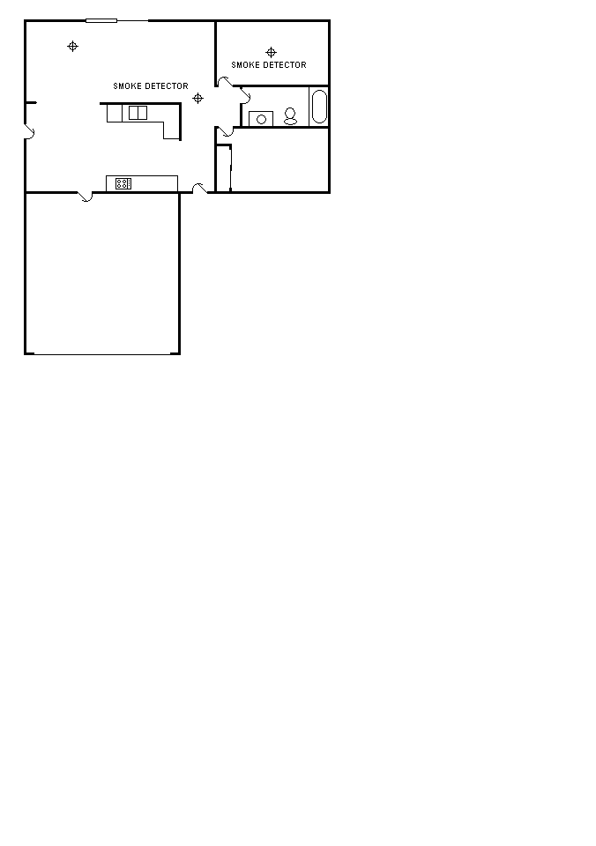

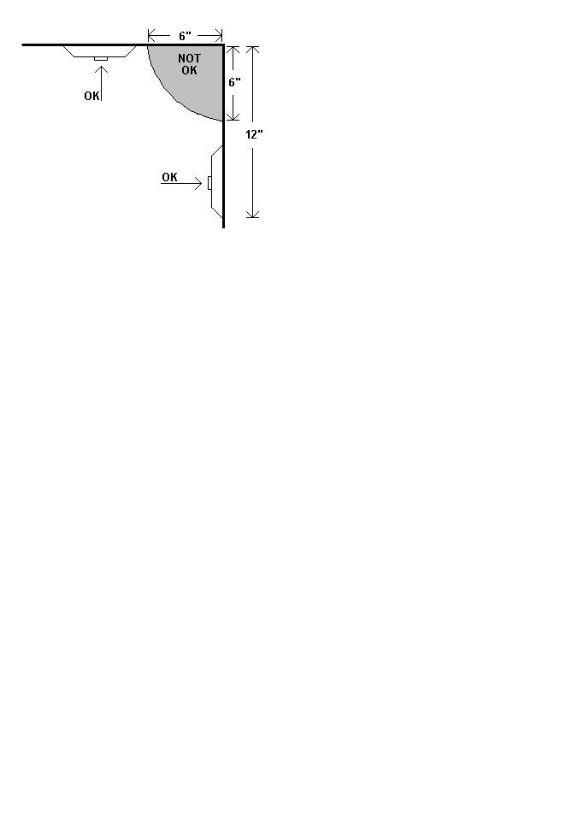**.**

The smoke detector should be mounted on the ceiling. Do not mount closer than 6 inches to the corner of the ceiling and the wall. In special cases where the smoke detector must be mounted on the wall, do not mount closer than 6 inches to the ceiling or further than 12 inches away.

(NFPA 72 §29.8.3.4, 2022 CFC 907.2.11.8)

*(2022 CFC and CBC 907.2.6.5)*

**Two Exits Required**

**Horn *OR* Bell must be audible throughout the home.**

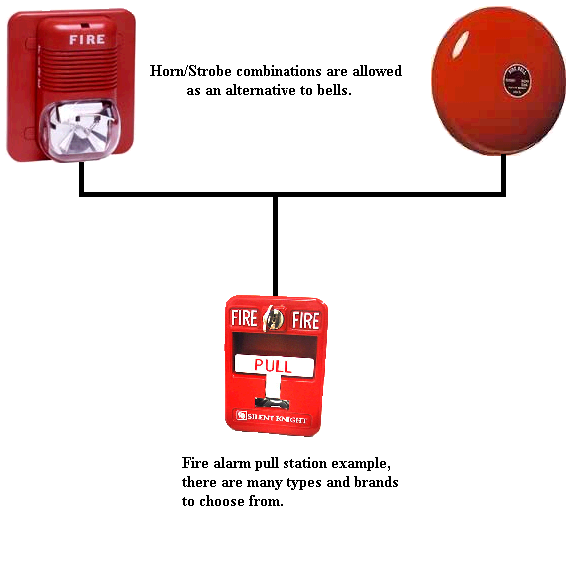

A sliding glass door may be used for one of the two exits. *(2022 CBC 1006.2.2.7)*

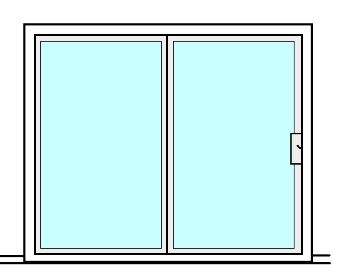

On Sliding Doors only the manufacturers locking hardware is allowed. No additional locks may be added.

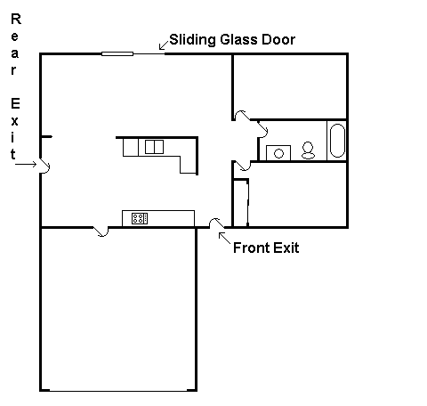

# Exits and Space Requirements

(*2022 CBC 1006.2.2.7)*

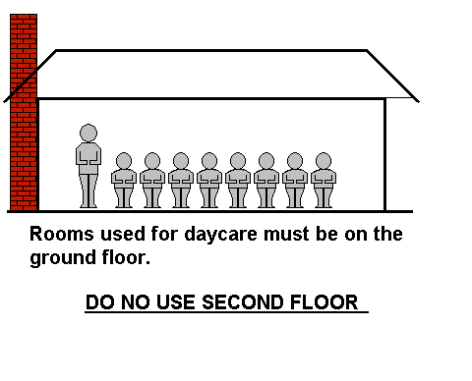

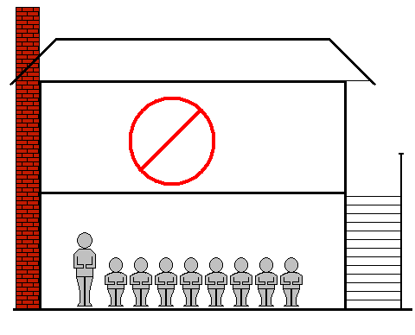

**Exceptions**

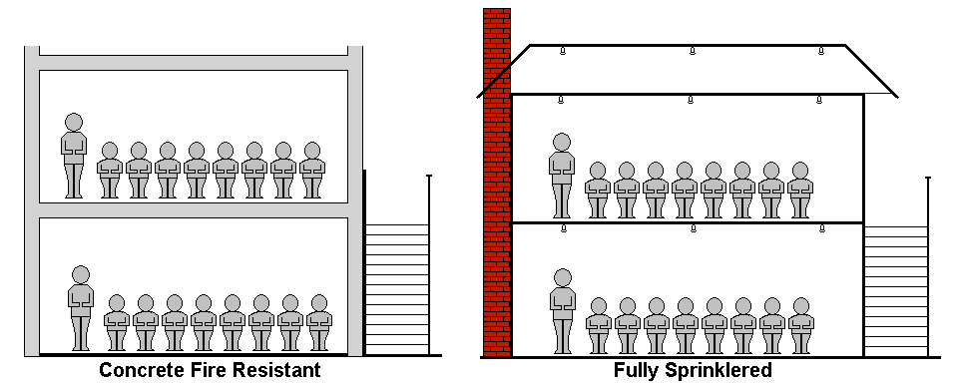

In concrete, fire resistant homes with an outside stairway

In homes with an approved automatic fire sprinkler system throughout and with an outside stairway.

**OR**



**Fire Extinguishers**

All fire extinguishers shall be mounted between 3 and 5 feet above the floor. The bottom of the extinguisher must have a 4 inch clearance from the floor.

Fire extinguishers must be visible and accessible.

*[2022 CFC 906.5, 906.9.1, 906.9.2, CCR Title 19, Div. 1, §567.6]*

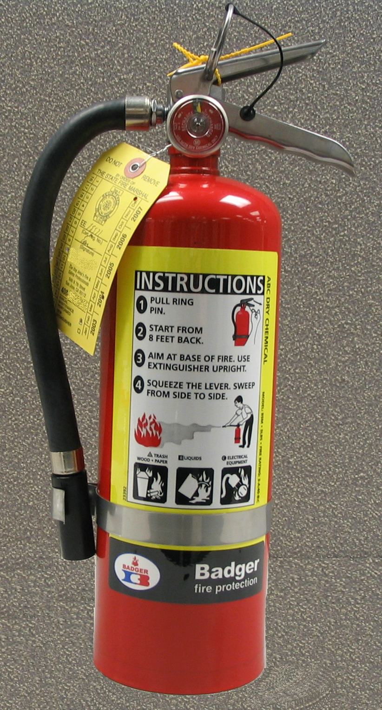

Provide a fire extinguisher, rated at least 2A:10BC, and be sure to install it correctly. Your fire extinguisher needs to be serviced annually, and after discharge, by a licensed technician and must have a State Fire Marshal Service Tag.

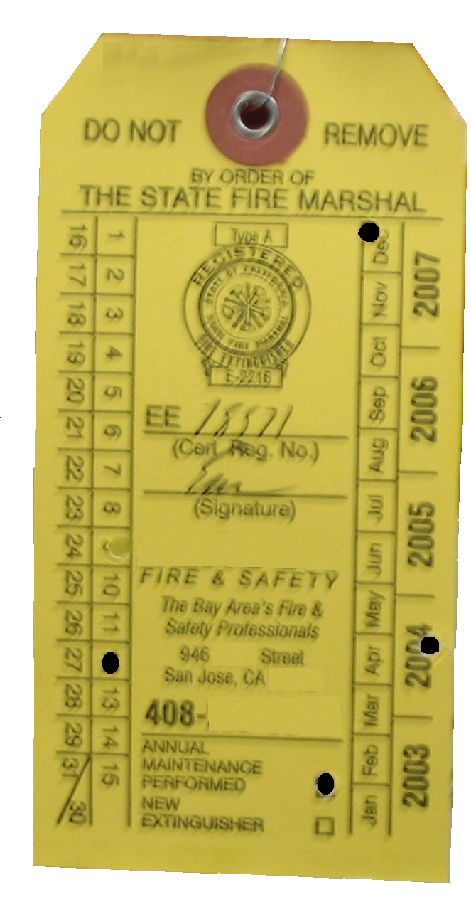

State Fire Marshal Service Tag:

Punched date indicates date of service not expiration date. The service is good for one year from punched date. A new extinguisher is good for one year from purchase date (must maintain the store receipt.)



### The Fire Extinguisher Rating/Classification,

such as 2-A:10-BC, may be found near the UL label



**Back Yard Gate:**

Side gates that are part of the exit path out to a public way must meet exit door requirements. An example of a simple, single action set-up would be wire/string with a handle at the children’s level that is attached to the normal gate latch. If the gate opens inward a handle at the children’s level is also required.

*[2022 CFC 1008.2]*