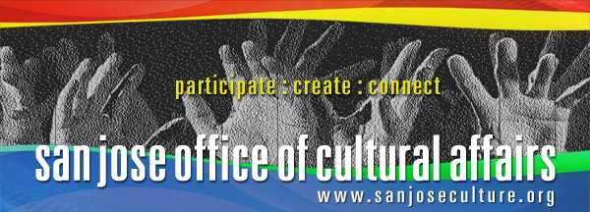

2024 Cornerstone of the Arts Awards
NOMINATION GUIDELINES
DEADLINE: May 3 by 5:00 p.m.
The San Jose Office of Cultural Affairs and the Arts Commission are pleased to announce this year’s nomination process for honoring exemplary art leaders.
Join us in celebrating the value that the arts bring to our community by nominating an inspiring person, organization, or artist that has made a cultural impact. Awards will be presented at the annual Cornerstone of the Arts event in October. Nomination guidelines are available in this packet and on the Office of Cultural Affairs website: www.sanjoseculture.org
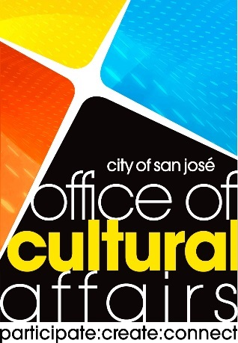
2024 AWARD CATEGORIES
This year’s award categories shine a spotlight on individuals, organization, and artists who have made a significant impact in strengthening the vibrancy of San Jose through their leadership and community impact.
- Cornerstone of the Arts Award – An individual(s) who has provided effective leadership and/or support over time, leading to the betterment of San Jose’s arts community and the quality of life for our citizens.

- Creative Impact Award – A cultural or artistic project, program, or special event that has made a significant impact on the community.

- Luminary Artist Award (NEW) – Recognizes an established, professional artist who has a substantial body of work that reflects excellence and contributions to San Jose’s cultural vitality.

NOMINATION PROCESS
Nominations are welcome from the public. Self-nominations are not accepted. Current Arts Commissioners are not eligible for nominations.
Applications must include the following:
- Nomination cover form
- Nominator’s statement

Nominations will be reviewed by a panel comprised of members of the Arts Commission, community representatives, and past award winners. The award recommendations of the panel will be submitted for approval by the Arts Commission. For each award, both the nominator and the honoree will be notified. In non-award cases, only the nominator will be notified.

IMPORTANT DATES
- May 3, 2024 Nomination Deadline
- June 17, 2024 Arts Commission approves nominees
- October 11, 2024 Awards Presentation

SUBMISSION GUIDELINES
- Packets must be received via email by FRIDAY, May 3, 2024 by 5:00 p.m.
- E-mail nominations packets to: culturalaffairs@sanjoseca.gov
  - Supporting materials are optional and can be provided as attachments. Hard copies of the supporting materials will not be accepted.
  - We will confirm receipt of all nominations promptly. Late or incomplete nominations will not be considered by the review panel.
Questions? Please contact Arts Program Coordinator Tina Iv at tina.iv@sanjoseca.gov or by phone at (408) 793-4348.

NOMINATION CHECKLIST | Incomplete nomination packets will not be reviewed.
☐ Nomination Cover Form
☐ Narrative
☐ Artwork samples (for Luminary Artist Award Category)
Please note: Nominators may be contacted directly with any follow-up questions and with the results of the panel review process. The Office of Cultural Affairs will not contact nominees unless they receive an award. Names of declined nominees will not be publicized.

NOMINATION COVER FORM
Nominees are not required to be residents of San Jose; however, majority of their artistic activities must have taken place within the city. Nominators are requested to abstain from nominations that may result in a perceived conflict of interest. It is suggested that the nominator contact the nominee for their consent.
Self-nominations are not accepted. Current Arts Commissioners are ineligible for nominations.

AWARD CATEGORY | Please check only ONE category per nomination.
☐ Cornerstone of the Arts Award
☐ Creative Impact Award
☐ Luminary Artist Award (New)
NOMINEE INFORMATION | Please type directly into the fields below.
Name of Nominee:
Nominee’s Position or Title:
Address:
City: State: Zip:
Telephone:
E-mail:

NOMINATOR INFORMATION | Anonymous nominations will not be accepted.
Name of Nominator:
Relationship to Nominee
Position or Title:
Organization:
Address:
City: State: Zip:
Email and telephone:

NARRATIVE GUIDELINES AND PROMPTS
The written narrative should clearly address the prompts below in the category for the nominee. Please use a standard 12-point font with 1” margins, not to exceed no more than 3 one-sided pages.

CORNERSTONE OF THE ARTS AWARD
Description: An individual(s) who has provided enduring and effective leadership and/or support that has led the betterment of San Jose’s arts community and the quality of life for our citizens.

Eligibility:
- An individual or individuals (not an organization)
- Working in any sector (nonprofit, public, or private)
- Past honorees are ineligible.
- Please visit OCA’s website to view a list of former Cornerstone of the Arts Honorees.

Narrative:
- Significance: The nominee’s contributions have a significant and long-lasting impact on the San Jose art and cultural landscape. This may be measured, but not limited to, by organizational development, fund development, audience size, artistic achievement, branding, stewardship, service, and commitment. The nominee has been highly effective in achieving positive change. His or her work/support has had a measurable record of accomplishment and has brought local, regional, or national recognition to San Jose.
- Please describe the nominee’s contributions that have had a significant and long-lasting impact on the San Jose art and cultural landscape.

- Innovation: The nominee has helped advance an innovative strategy that directly improves the cultural environment of San Jose. The work represents a leap in creativity or a fundamental departure from usual practice.

- How has the nominee advanced innovative strategies that directly improved the cultural environment of San Jose?

See next page for additional questions.

- Inclusiveness: The nominee helps build bridges among people with differing viewpoints and/or different backgrounds. The nominee’s work has a positive influence on San Jose’s diverse and underrepresented populations. The nominee cultivates greater visibility and value of the arts. The nominee demonstrates an interest in mentorship and collaboration, sharing their ideas and ideals with the arts and culture community.

- How does the nominee build bridges among people with differing viewpoints or backgrounds?

- Timing of Recognition: The nominee’s accomplishments are at a stage at which this recognition could substantially enhance its probability to inspire replication or emulation.

  - Are the nominee’s accomplishments at a stage at which this recognition could substantially enhance its probability to inspire replication or emulation? If so, please explain.

CREATIVE IMPACT AWARD
Description: A cultural or artistic project, program, or special event that has made a significant impact on the community.

Eligibility:
- An individual or individuals from either the nonprofit or business sector.
- Produced a special cultural or artistic project, program, or event that has significantly impacted the San Jose community.
- Special cultural or artistic project or event can be, but does not have to be reoccurring.
- Past honorees are ineligible.

- Please visit the OCA’s website to view the list of former Creative Impact Honorees.

Narrative:
- Significance of Project:
- Provide an overview of the nominee’s cultural or artistic project, program, or special event.
- Why is this project, program, or event significant to the community?
- Please provide samples or examples of the project, program, or event.

- Community Impact:
- Describe how the nominee’s cultural or artistic project, program, or special event has impacted the community.
- How did the nominee’s project, program, or event engage the community as a whole?
- Please list the City Council district where the project, program, or event was produced.

- Innovation:
  - How innovative was the nominee’s cultural or artistic project, program, or special event?
  - How is this project, program, or event unique?
  - What kind of approaches did the nominee use to make this project, program, or special event innovative?

LUMINARY ARTIST AWARD
Description - Recognizes an established, professional artist who has a substantial body of work that reflects excellence and contributions to San Jose’s cultural vitality.

Eligibility:
- Artist must have lived or worked in San Jose for a minimal of five (5) years.
- Artist must have contributed to the cultural enrichment in San Jose.
- Past honorees are ineligible.

Narrative:
- Significance of Work:
- Provide an overview of the the nominee’s contribution to their artistic field.
- Please provide up to six (6) work samples that the nominee has produced in the community.

- Community Impact:
- Describe how the nominee’s work has impacted the community.
- How did the nominee engage the community as whole?

- Collaboration:
  - Does the nominee collaborate with other artists? If yes, please describe how the nominee has collaborated with the arts community. Please provide examples.
- Innovation:
  - What techniques did the nominee use to make their work creative and innovative?

