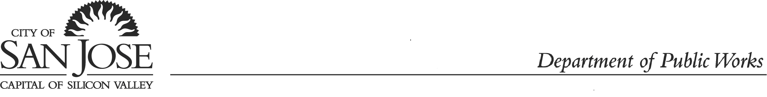

Engineering Services Division, Building Official Program

PUBLIC WORKS’ CODE INSPECTOR’S CONTACT INFO

Supervising Inspectors

Ralph Ramirez Jose Carvallo
E-mail: Ralph.Ramirez@sanjoseca.gov E-mail: Jose.Carvallo@sanjoseca.gov
Phone # Cell (408) 975-7353 Phone # Cell (408) 975-7446

Building Inspectors

Yen-Thanh Ho Emmanuel Mendoza Tobares
E-mail: Yen-Thanh.Ho@sanjoseca.gov E-mail: Emmanuel.mendoza@sanjoseca.gov
Phone # Cell (408) 613-3640 Phone # Cell (408) 476-5524

Electrical Inspectors
Armand Nascimento Ed Crump
E-mail: Armand.Nascimento@sanjoseca.gov E-mail: Ed.Crump@sanjoseca.gov
Phone # Cell (408) 975-7445 Phone # Cell (408) 975-7140

Emmanuel Mendoza Michael Vu
E-mail: Emmanuel.Mendoza@sanjoseca.gov Michael.Vu@sanjoseca.gov
Phone # Cell (408) 476-5524 Phone # Cell (408) 930-2796

George Gonzalez Pat Anchondo
E-mail: George.Gonzalez@sanjoseca.gov E-mail: Pat.Anchondo@sanjoseca.gov
Phone # Cell (408) 931-0653 Phone # Cell (408) 221-0572

Plumbing/Mechanical Inspectors
Brian Marshall Terry Morgan
E-mail: Brian.Marshall@sanjoseca.gov E-mail: Terry.Morgan@sanjoseca.gov
Phone # Cell (408) 506-7881 Phone # Cell (669) 293-2353

REV 7/1/2024

