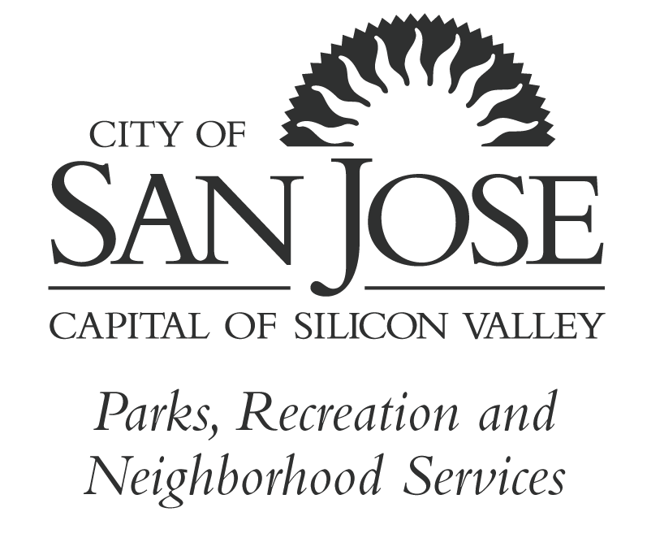
City of San José
Youth Commission

District 1 – Deepankar Joshi Nathan Arumugham – District 2
District 3 – Maren Bick-Maurischat Kaitlyn Tran – District 4
District 5 – Sofia Jaquez – District 6
District 7 – Jenifer Herrera-Damian Rushil Srivastava – District 8
District 9 – Clarabelle Walkup Dheerj Jasuja – District 10
Citywide – Jacqueline Paredes-Kao

ANNUAL RETREAT AMENDED MINUTES
August 10 – 12, 2018

Start: Friday, August 10, at 4:30 p.m. Almaden Winery Community Center
End: Sunday, August 12 5730 Chambertin Dr.
San Jose, CA 95118

I. Call to Order & Orders of the Day
All commissioners were in attendance.
Commissioner Srivastava
Member of the public, Chris Zazueta

II. Public Comment – Parks, Recreation and Neighborhood Service Superintendent, Hal Spangenberg welcomed the commissioners and wished them to a successful year.

III. Announcements – Staff shared the upcoming District 2 and 9 Community Events.

IV. Consent Calendar – None

V. Reports
- Commissioners presented their summer commission work
- Staff report – reported on the city email process

V. New & Returning Business
During the Youth Commission retreat, commissioners participate in the following team and leadership activities and received their commission binders:
- Leadership
a. Identifying leadership style
b. Parliamentary procedures,
d. Brown Act
e. Agendas, minutes, and bylaws

B. Team-Building Activities:
- Youth Commission core values
- The courage of standing up and standing out
- The power of inclusion

- Commission Structure
- Commission’s Mission, Vision, and Core Values
- Youth Commission positions within city government
- Commission guiding tools
- Work plan
- Commission bylaws
- Meeting structure
- Reporting template
- The process of making a recommendation
- Reports and one-on-one meetings
- Executive board role and responsibilities

- Retreat Guest Summer Interns - Presented their Research Proposals
- Air Pollution
- Consent
- Youth Vote Registration
- Gang Reduction

- Brainstorm Activities – Commissioners participated in the following brainstorm
activity:
- Identifying and prioritizing youth issues throughout the city
- Identify citywide youth event for implementation
- Identify youth ad hoc groups
- Reviewed and discussed the summer intern’s presentations
- Discussed the Youth Advisory Council structure and development
- 2018−2019 Work Plan Creation and Development (August 12, 2019) - Commissioners participated in the development of the 2018/19 Youth Commission work-plan.
- Work plan purpose
- Work plan S.M.A.R.T. goals and objectives
- Overview of the 2017-2018 work plan accomplishments
- Work plan evaluation and final recap

- Executive Board Elections – Commissioners conducted nominations and elections for the 2018-2019 Youth Commission Chair, Vice Chair, and Second Vice-Chair through a ballot vote. The following is the voting results:
  - Commission Chair goes to Commissioner Bick-Maurischat
  - Vice Chair go to Commissioner Joshi
  - 2nd Vice Chair goes to Commissioner Jaquez

VI. Adjournment
Sunday, August 12, 2018

The City of San José is committed to open and honest government and strives to consistently meet the community’s expectations by providing excellent service, in a positive and timely manner, and in the full view of the public.

You may speak to the Commission about any discussion item that is on the agenda, and you may also speak during Public Comments on items that are not on the agenda and are within the subject matter jurisdiction of the Commission. Please be advised that, by law, the Commission is unable to discuss or take action on issues presented during Public Comments. Pursuant to Government Code Section 54954.2, no matter shall be acted upon by the Commission unless listed on the agenda, which has been posted not less than 72 hours prior to meeting.
Agendas, Staff Reports and some associated documents for the Commission items may be viewed on the Internet at http://sanjoseca.gov/prns/youthcommission
All public records relating to an open session item on this agenda, which are not exempt from disclosure pursuant to the California Public Records Act, that are distributed to a majority of the legislative body will be available for public inspection at the Office of the City Clerk, 200 East Santa Clara Street, 14th Floor, San José, California 95113, at the same time that the public records are distributed or made available to the legislative body. Any draft resolutions or other items posted on the Internet site or distributed in advance of the commission meeting may not be the final documents approved by the commission. Contact the Office of the City Clerk for the final document.
On occasion the Commission may consider agenda items out of order.
The Youth Commission meets every 4th Monay of each month at 6:30pm, with special meetings as necessary. If you have any questions, please direct them to the Commission staff. Thank you for taking the time to attend today’s meeting. We look forward to seeing you at future meetings.
To request an accommodation or alternative format under the Americans with Disabilities Act for City-sponsored meetings, events or printed materials, please call (408) 535-1260 as soon as possible, but at least three business days before the meeting.
Please direct correspondence and questions to:
City of San José
Attn: Betty Ramirez
200 East Santa Clara Street
San José, California 95113
Tel: (408) 535-5559
Email: YouthCommission@sanjoseca.gov

