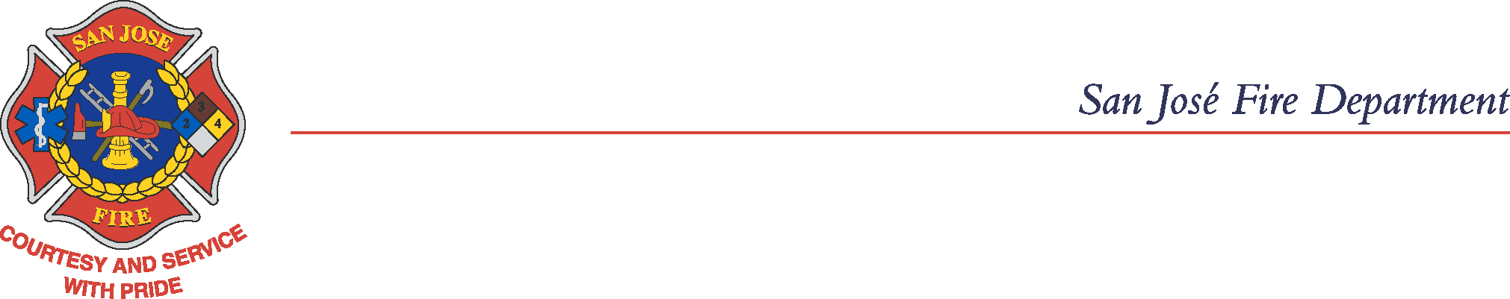

April 15, 2021

Dear Fire Safety and Hazardous Materials Permit Holder,

This letter is to notify you of a proposed 8% increase to all Fire Safety and Hazardous Materials permit and related fees. If approved, the fee change will be effective July 1, 2021.

You are invited to observe the following meetings on the tentative dates listed below. Please visit https://www.sanjoseca.gov/news-stories/city-calendar/ for updated dates and times.

Fees and Charges Study Session Friday, May 14, 2021
Public Hearing Tuesday, May 18, 2021
Final Public Hearing Monday, June 14, 2021

The release date for the 2021-2022 Proposed Fees & Charges Report is Friday, May 7, 2021.
The fees and charges document will be available after May 7, 2021 for viewing online at https://www.sanjoseca.gov/your-government/departments-offices/office-of-the-city-manager/budget/budget-documents

Please disregard this notice if you are exempt from San José Fire Department Fire Safety or Hazardous Materials annual permit fees.

You may contact the San José Fire Department Billing Unit by email at sjfd.billing@sanjoseca.gov or by phone at (408) 795-1869.
Sincerely,

Hector R. Estrada
Fire Marshal

*COVID-19 Notice: Consistent with the California Governor’s Executive Order No. N-29-20, Resolution No. 79485 from the City of San José and the Santa Clara County Health Officer’s March 16, 2020 Shelter in Place Order, the City Council meeting will not be physically open to the public and the City Council will be teleconferencing from remote locations.
How to observe the Meeting (no public comment):

1) Cable Channel 26,
2) https://www.sanjoseca.gov/news-stories/watch-a-meeting, or
3) https://www.youtube.com/CityofSanJoseCalifornia

