**PREVIOUS AWARDS**

**2nd Annual Climate Smart Champions Awards 2020**

Watch the [video](https://youtu.be/Rude4CKWJZo) to hear directly from all our Champions about what drives them to be climate leaders in the community.

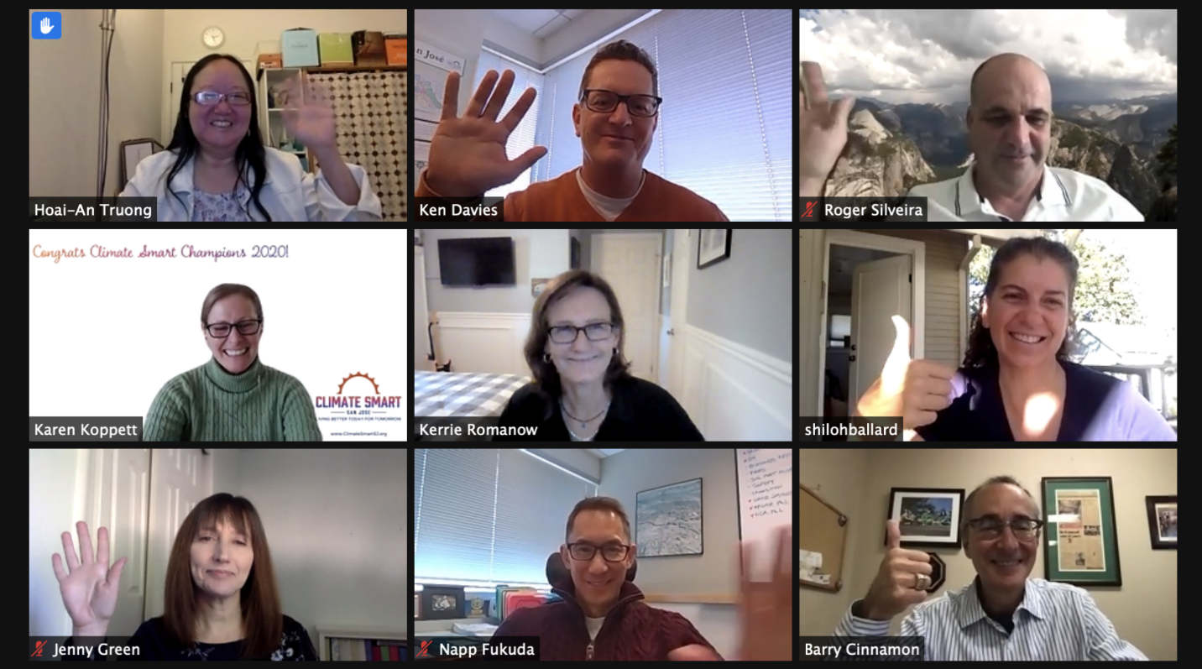

Awards were granted in the following categories:

* Climate Smart Mobility Champion: Shiloh Ballard
* Climate Smart Energy Champion: Barry Cinnamon
* Climate Smart Water Champion: Karen Koppett
* Climate Smart Community Champions: Hoai-An Truong and Jenny Green, Team Climate Warriors, Climate Smart Challenge
* Climate Smart Youth Champion: Students at East Side Union High School District

**1st Annual Climate Smart Champions Awards 2019**

Awards were granted in the following categories:

Climate Smart Champion of the Year (two Champions recognized): San José Community Energy Advocates and Mothers Out Front South Bay

Outstanding Transportation Champion: Jaime Fearer, California Walks/Walk San Jose

Development Champion: CBRE

Energy Efficiency Champion: Chris Funk, East Side Union School District

Water Conservation Champion: Adam Salvadalena, San José State University

City Employee Champion: Angel Ibanez, Office of San José Mayor Liccardo

Youth Climate Champion (three Champions recognized): Mothers Out Front South Bay Youth: Anika Knowles, Karina Knowles, Ariana Habermann