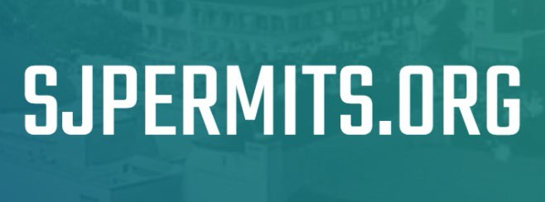

**Apply on Behalf of**

**This guide will cover the following topics:**

Overview 1

Applying for Permit 2

Apply on Behalf of Collaboration Role 2

Contacting Staff to Use Apply on Behalf of Feature 3

# **Overview**

At [SJPermits.org](http://www.sjpermits.org/) applicants will have the ability to “Apply on Behalf of” a person or organization. This is advantageous when the user filing the online application does not wish to be the designated “Applicant” of the application. To apply on behalf of a person or organization, your online account must first be linked to another record in our system as a “Member.” The different membership types are:

* Business Owner
* Property Owner
* Partner
* Employee
* Contract Employee
* Authorized Applicant

There are no limits to number of organizations a user can be a member of, and the user may have different membership types in each. However, a user can only be listed with one membership type per organization.

# **Applying for Permit**

If you try to apply for a permit and you do not see the “Apply on Behalf of” drop down menu item, as illustrated below, this means your account is not associated as a member of any person or organization. To be associated with a person or organization, as a member, the user or organization must provide relevant backup documentation to City staff. With the information City staff will add the relevant membership type to the user.

# **Apply on Behalf of Collaboration Role**

When a user utilizes the “Apply on Behalf of” feature, the standard functionality of default collaborators will differ from a normal application. Depending on the user’s membership type the default application collaborators that will be present on the “Project Collaborators” screen will differ. Below is a table that will list what default collaborators will be inserted depending on the membership role of the user applying for the permit:

|  |  |  |  |  |
| --- | --- | --- | --- | --- |
|  | **Application Collaborator Roles** | | | |
| **Membership Role** | **Applicant** | **Contact** | **Organization** | **Owner** |
| Business Owner | User Applying for Permit | N/A | Organization being Applied on behalf of | Owner of Primary Property (if applicable) |
| Property Owner |
| Partner |
| Employee |
| Contract Employee |
| Authorized Applicant | Organization being Applied on behalf of | User Applying for Permit | N/A |

# **Contacting Staff to Use Apply on Behalf of Feature**

To get an account associated with an organization or person, you should contact the applicable staff for the permit you are applying for.

For Public Works, if your project went through an entitlement process, you should already have the names of the Public Works staff assigned to your project. If you are unaware of who your contact is, depending on your permit application, send your request to the following email:

* Public Works Development Services: [pwgeneralinfo@sanjoseca.gov](mailto:pwgeneralinfo@sanjoseca.gov)
* Public Works Inter-Agency: [pwinteragency@sanjoseca.gov](mailto:pwinteragency@sanjoseca.gov)
* Public Utilities: [pwutilitypermits@sanjoseca.gov](mailto:pwutilitypermits@sanjoseca.gov)

For applications for other divisions the email contacts are as follows:

* Building Division: [BuildingPermits@sanjoseca.gov](mailto:BuildingPermits@sanjoseca.gov)
* Fire Department: [SJFDPermitSpecialist@sanjoseca.gov](mailto:SJFDPermitSpecialist@sanjoseca.gov)
* Planning Division: [ZoningQuestions@sanjoseca.gov](mailto:ZoningQuestions@sanjoseca.gov)