

**Property Search and Selection Guide**

# **Overview**

During your online application at [SJPermits.org](http://www.sjpermits.org/) you will be asked to add the property(ies) associated with your proposed project. These are broken down into two categories of properties: Primary Property and additional properties.

The Primary property should typically be the largest of the parcels, street segment or intersection you are proposing the work on. However, you may select any property, street segment or street intersection as your primary property. Additional properties are the other properties that are also associated with your proposed project.

Except for Public Utility Permits, issued by the Department of Public Works, you will be presented with three different options to search for your primary property. Public Utility Permits will only be presented with one option which is identified as the third bullet below. This guide will provide guidance on utilizing the different search options to add the property(ies) to your application. The options for property searches are:

* Search by Assessor Parcel Number (APN)
* Search by Address
* Search by Street Segment or Intersection

**This guide will cover the following topics:**

Overview 1

Section 1 - Assessor Parcel Number (APN) Search: 2

Section 2 - Address Search: 4

Section 3 - Street Segment / Street Intersection Search 7

Section 4 – Primary Property Selection 10

Section 5 – Additional Properties 11

Section 5.1 – Adding Additional Properties (Optional) 12

Section 5.2 – Delete Properties from Application (Optional) 13

# **Section 1 - Assessor Parcel Number (APN) Search:**

**Overview**

APNs are broken down into three sections: Book (3 digits), Page (2 digits) and Lot (3 digits) with a format that is typically shown as BBB-PP-LLL. If the book, page or lot number is low enough where it wouldn’t contain the total digits indicated (i.e. 1, 3, 5, etc.) then a zero is added in front where 1 would be shown as 01 if the section requires 2 digits or 001 if the section requires 3 digits.

To search using the parcel APN, you will need to know the County of Santa Clara Assessor Book, Page, and Parcel number of the property(ies). If you do not know the APN numbers of the properties, you can search for your property on the [County of Santa Clara’s Interactive Map](https://www.sccassessor.org/online-services/property-search/search-by-map). You can search by inputting an address or intersection. Once you are taken to the page you can click on the property and it will list the APN number of the lot.

**Performing the Search**

During your online application at SJPermits you will see the box below to search using the APN:

To search for the property using APN you will need to search as a string of numbers, without the dashes that are typically associated with APNs. So, as described in the search box above, if you have an APN of 235-12-003 then you would search for the property as 23512003.

When selecting the Primary Property, as described in Section 4, the more precise the APN you input into the search box, the quicker the search and selection will be.

You can also do partial searches to find a group of properties. Partial searches using portions of the APN would be the most beneficial when trying to add the additional properties, associated with your permit application, as described in Section 5.

For partial searches you will utilize “wildcards” by using the percent (%) symbol in front of, behind or in combination of your search criteria. Below are some examples of utilizing wildcards.

* **BBB%** - inputting a string of 3 numbers followed by the wildcard symbol will allow you to search for all properties that match that APN Book number. For example, if you enter 261% you will find all properties that are in the book 261.
* **BBBPP%** - inputting a string of 5 numbers following by the wildcard symbol will allow you to search for all properties that match that APN book and page number. For example, if you enter 26113% your search will result in all properties that are in book 261 and page 13.
* **%LLL** - inputting the wildcard in the beginning followed by a string of 3 numbers will allow you to search for all properties that match that lot number. For example, if you enter %003 your search will return all properties that have a lot number of 003 regardless of the book or page number.
* **%######%** - inputting a string of numbers between two wildcard symbols will allow you to search for properties that fit the criteria, regardless of the book, page or lot number. For example, if you enter %113% your search results would include all properties that contain that string anywhere in the APN. Examples results would be 26456**113**, 4844**113**3, 70**113**023, etc.

**Note:**  There are other wildcard combinations you may try. However, the above combinations are the ones recommended to search for properties to add to your application utilizing the APN search box.

# **Section 2 - Address Search**

**Overview**

During your online application at SJPermits you will see the “Search by Address” box to search by the property address. The address search can be used if the property address(es) is/are known or if a search by APN does not yield a result that matches the property, which the application is being applied for. Some properties within the City of San Jose do not have an address and may show with the result of “0” in front of the street name, such as “0 W Santa Clara Street.” In these instances, the property should be searched by APN instead of by property address, refer to Section 1 for instructions on how to search by APN.

**Performing the Search**

Address searches are searchable by three categories. There are these are:

1. **House or Building Number** – The house or building number is the number associated with the mailing address. Only numbers should be used in this box as anything other than a number will not return any results.
2. **Street Name** – This is the street name that appears on the mail that is received at the property. To perform the search using street name, you can’t use the street direction (i.e., N, S, E or W) or the street type (i.e., Avenue, Street, Court, etc.). For example, if the property was located at W Santa Clara Street, you would only enter “Santa Clara” in the Street Name box. If you enter “W Santa Clara Street” your search will not return any results.
3. **Unit Number** – This only applies for condominium units, apartment units and in some cases retail spaces. When searching using the unit number, either numbers or letters can be used in this search box.

When selecting the Primary Property, as described in Section 4, the more precise the site address you input into the search box, the quicker the search and selection will be.

You can also do partial searches to find a group of properties. Partial searches using portions of the site address would be the most beneficial when trying to add the additional properties as described in Section 5.

Partial address searches can either include just filling out one or two of the search criteria described earlier or using “wildcards.” Wildcards are used by adding the percent (%) symbol in front of, behind or in combination of your search criteria. Wildcards can be used in any of the search boxes. However, for illustrative purposes, the examples below will only focus on the Street Address portion of the address search.

* **XXXXXXXXX%** - inputting text followed by the wildcard symbol will allow you to search for properties that match results that begin with that text string. For example, if you enter San% the search results displayed will begin with “San” such as: **San** Carlos Street or **San**ta Clara Street.
* **%XXXXXXXX** - inputting the wildcard in the beginning followed by text will allow you to search for properties that end with that text string. For example, if you enter %Low the search results displayed will end with “Low,” such as: Wil**low** Street, Pine Hol**low** Circle, or Houns**low** Drive.
* **%XXXXXXXX%** - inputting a text string between two wildcard symbols will allow you to search for properties that fit the criteria, regardless of where the text string is in the address. For example, if you enter %Wood% the search results displayed will include all properties that contain that string anywhere in the street name, such as: Drift**wood** Drive, El**wood** Drive, or **Wood**ranch Drive.
* **XXXXXX%XXXXXX%** - inputting a text string followed by a wildcard and then adding more text followed by a wildcard symbol will allow you to search for properties that begins with a certain text string and then contains another text string anywhere else in the address. For example, if you enter San%Los% the search result will include all properties that begins with “San” and then contains “Los” anywhere else in the street address, such as: **San**d B**los**som Street or W **San** Car**los** Street.

**Note:**

* In order to assist you in finding the property address you may also utilize the City of San Jose [Public GIS Viewer](https://csj.maps.arcgis.com/apps/webappviewer/index.html?id=3c5516412b594e79bd25c49f10fc672f) by clicking the link or by going to [www.sanjoseca.gov/pwresources](http://www.sanjoseca.gov/pwresources). From the Public Works Resource page, click on the Public GIS viewer button to launch the GIS viewer. The property addresses are shown as “site address points” on the map and are indicated by green circles on the property. You can view the address by zooming in or by clicking on the green circle associated with property. An example image is shown below.
* Numbered streets such as 1st Street, 2nd Street, etc. must be searched for as a number in the street address box as “1ST" or “2ND." If the search is attempted as “first” or “second” no results will be displayed.
* There are other wildcard combinations you may try. However, the above combinations are the ones recommended to search for properties to add to your application utilizing the address search box.



# **Section 3 - Street Segment / Street Intersection Search**

**Overview**

For Public Works permit applications on SJPermits, you will see the “Search by Street Segment or Intersection” box. This allows you to add public streets, private streets or intersections as part of your permit application.

For this permit application process, street segments and intersection are defined below. An example street layout is also provided, for illustrative purposes, to assist with the definitions.

* **Street Segment** – A line between two intersection points. As shown in the example below Street segments are labeled as Street A, Street B, etc.
* **Intersections** – The point where two or more street segments intersect or where a street segment terminates at the end of a road, such as a cul-de-sac. In the example below, the intersections are shown as circles

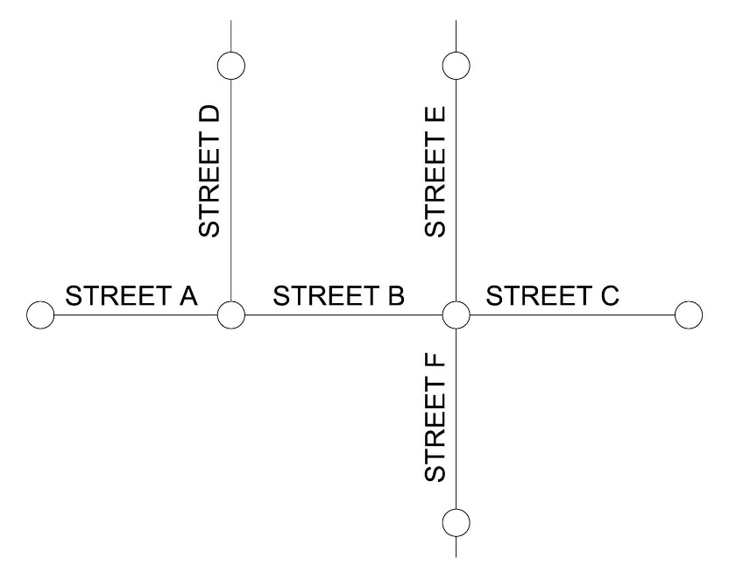

Street segments or intersections should be added to the permit application, in combination with properties, if the work proposed will be occurring in the street. Typical permits that could include street segments or intersections are revocable encroachment permits, sewer lateral permits, public improvement permits, etc.

Permit applications that propose work on private property only, should not add street segments or intersections as part of the permit application. Typical permits that should not include street segments or intersections are grading and drainage permits, geologic clearances, parcel maps and tract maps.

For Public Utility permits, street segments or intersections are the only types allowed to be added to the permit application.

**Performing the Search**

Street segments and intersection searches are searchable by three categories. All three search categories can be used individually or in combination to retrieve result. These are:

1. **Street Name** – This box should only be used when searching for a street segment. It should not be used when searching for an intersection. The street name is the name of the street where the work is occurring that is happening between the two intersection points. **Note:** To perform the search using street name, you can’t use the street direction (i.e., N, S, E or W) or the street type (i.e., Avenue, Street, Court, etc.). For example, if the street segment is on W Santa Clara Street, you would only enter “Santa Clara” in the Street Name box. If you enter “W Santa Clara Street” your search will not return any results.
2. **Street Location** – This box should be used for both street segments and intersections. The way to use this search varies on if you are using it to search for a street segment or intersection. The difference is identified below.
   * **Street Segment** – Street locations are the cross-streets / intersections along the “street name.” For example, using the street layout from the previous section, if work is happening on Street B then the street location to identify a specific section is by using Street D, Street E or Street F. The street location results will display, using the example shown earlier, as “From Street D to Street E” or, in the case of a cul-de-sac, “From Street E to End of Street.”
   * **Intersections** – The street location for intersections are the street names that intersect at the circle. For example, using the street layout from the previous section, the intersection the work is occurring is at the circle where Street A, B, & D meet. If you assume Street A & B have different street names, then the street location would show as: “Street A & Street B & Street D.”
3. **Type** – This is a dropdown selection that allows you to search by Street Segment or by Intersection. By default, if this is left blank, the search will check for both street segment and intersections.

When selecting the Primary Property, as described in Section 4, the more precise the street segment or street location you input into the search box, the quicker the search and selection will be.

You can also do partial searches to find a group of street segments or intersections. Partial searches using portions of the street name or street location address would be the most beneficial when trying to add the additional properties as described in Section 5.

Partial address searches can either include just filling out one or two of the search criteria described earlier or using “wildcards.” Wildcards are used by adding the percent (%) symbol in front of, behind or in combination of your search criteria. Wildcards can be used in any of the search boxes. However, for illustrative purposes, the examples below will only focus on the Street Location portion of the address search.

* **XXXXXXXXX%** - inputting text followed by the wildcard symbol will allow you to search for properties that match results that are anywhere in the street location. For example, if you enter 4th% the search results displayed will contain “4th" anywhere in the location field.
* **%XXXXXXXX** - inputting the wildcard in the beginning followed by text will perform the search as previously described.
* **%XXXXXXXX%** - inputting a text string between two wildcard symbols will perform the search as previously described.
* **%XXXXXX%XXXXXX%** (**Street Location Only)** - If you enter two wildcard criteria in the street location box it, the search will search for a combination of the two in reverse order. For example, if you put %Santa%4th% in the street location box, the results will show street locations that have “Santa” followed by “4th" and results that have “4th” followed by “Santa.” See the image below for an example of this.

**Note:**

* In order to assist you in visualizing the street segment and intersection, you may also utilize the City of San Jose [Public GIS Viewer](https://csj.maps.arcgis.com/apps/webappviewer/index.html?id=3c5516412b594e79bd25c49f10fc672f) by clicking the link or by going to [www.sanjoseca.gov/pwresources](http://www.sanjoseca.gov/pwresources). From the Public Works Resource page, click on the Public GIS viewer button to launch the GIS viewer.
* Numbered streets such as 1st Street, 2nd Street, etc. must be searched for as a number in the street address box as “1ST" or “2ND." If the search is attempted as “first” or “second” no results will be displayed.
* There are other wildcard combinations you may try. However, the above combinations are the ones recommended to search for properties to add to your application utilizing the street address or location search box.

# **Section 4 – Primary Property Selection**

After you submit your search you will be presented with the search results. From here you will be able to:

1. Adjust the number of results shown on the screen
2. Filter through the results utilizing the “Search” box at the top right
3. Select your Primary Property by clicking on the “Select” button next to the Property you wish to make your primary property.

**2**

**3**

**1**

# **Section 5 – Additional Properties**

Once you have selected your primary property you will be on the Additional Property Screen. Here you will see summary information for your permit so far. This includes a summary of the Application Type, Primary Property Details and Applicant People information. If your project spans multiple properties or multiples streets and/or intersections, you will want to add all pertinent properties to your application. This page is where you will do that.

On this page you will also have the options to cancel the application or to continue to the next step, if you don’t have any additional properties to add. To add more properties to your application, click on the “Add Additional Property” button and go to Section 5.1 of this document. If you don’t have any additional properties to add then click on the “Next” button and go to the next step in the permit application.

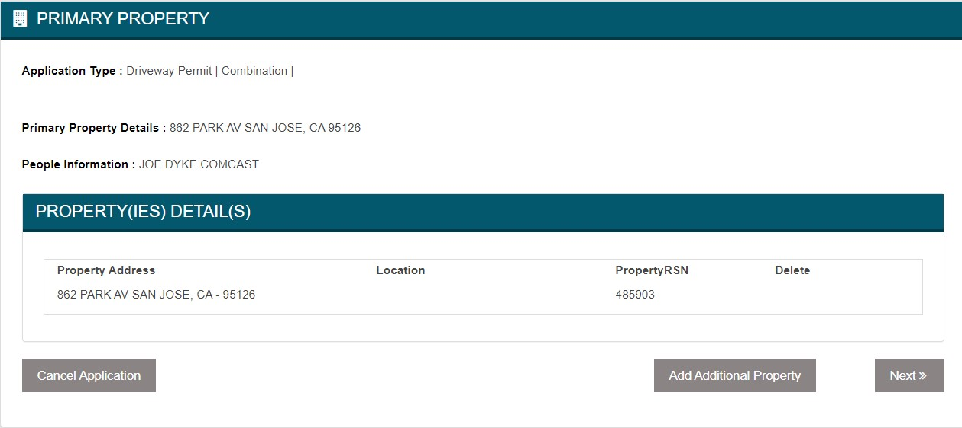

## Section 5.1 – Adding Additional Properties (Optional)

Click on the “Add Additional Property” button and you will be presented with the same property search options as shown and discussed in Section 1 through 3. After you submit your search the results page differs from the Primary Property selection screen, with some exceptions. From this screen you will be able to:

1. Adjust the number of results shown on the screen
2. Filter through the results utilizing the “Search” box at the top right
3. Select the Property(ies) that pertain to your application from the search results. You will select the property(ies) by clicking on the check box in the “Select” column. Properties can be selected from any of the search result pages and they do not have to still be shown on the screen to be added to the permit. See the other guides and videos on adding properties for more information.
4. Add the Property(ies) to the application by clicking on the “Add Property(ies)” button
5. Click on the “Continue” button to return to the main “Additional Property Screen” without adding any properties.
6. Click on the “Return to Property Search” to perform a different search if the property(ies) you were looking are not present from your previous search.

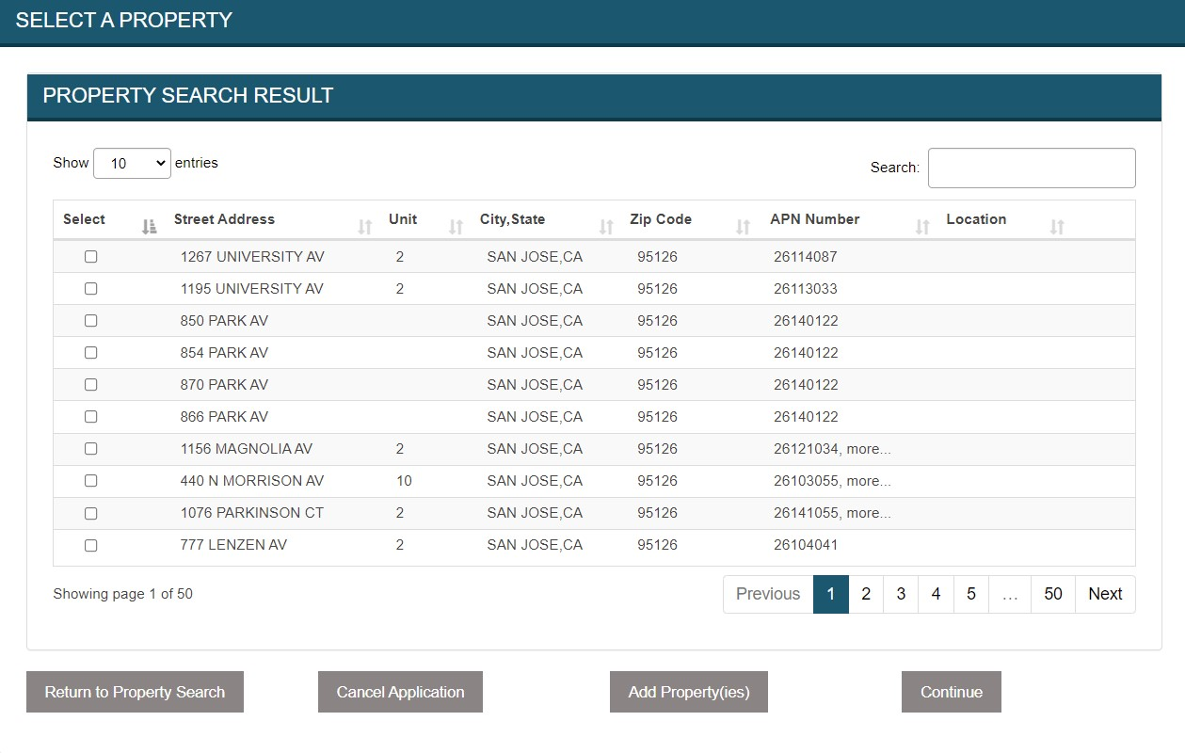

**6**

**3**

**5**

**4**

**2**

**1**

## Section 5.2 – Delete Properties from Application (Optional)

Once you have added the property(ies) to your application you will be redirected back to the Additional Property screen. The screen will now contain property(ies) you added to your application. You would have the ability to repeat the process if you needed to add more properties to your application. You can also delete any properties that were added by mistake, except for the Primary Property, by clicking on the “Delete” button next to the property.

