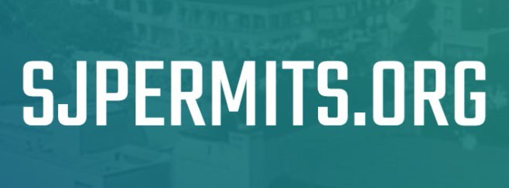

**Public Works Application Overview Guide**

At [SJPermits.org](http://www.sjpermits.org/) you can apply for a variety of Public Works permits. For a complete listing of the available permits please visit the [Public Works Online Application Page](https://www.sanjoseca.gov/your-government/departments-offices/public-works/public-works-development-services-online-applications). This guide provides an overview on the Public Works application process. For your submittal to be deemed complete, to begin the initial review process, you must complete Steps 1 through 8 as outlined in this guide. If you have any issues with your account, please send an email to: [OnlinePermits@sanjoseca.gov](mailto:OnlinePermits@sanjoseca.gov)

**This guide will cover the following topics:**

**Step 1 – Applying for the Permit** 2

**Step 2 - Choosing the Application Type** 3

**Step 3 – Select Your Primary Property** 4

**Step 4 – Selecting Additional Properties** 6

Step 4.1 – Add Additional Properties (Optional) 7

Step 4.2 – Delete Properties from Application (Optional) 8

**Step 5 – Adding Project Collaborators** 9

Step 5.1 – Add New Collaborator (Optional) 10

Step 5.2 – Add Additional Roles to an Existing Collaborator (Optional) 12

Step 5.3 – Delete Collaborators (Optional) 13

**Step 6 – Adding Project Information** 14

**Step 7 – Upload Application Attachments** 15

Step 7.1 – Review and/or Delete Attachments (Optional) 16

**Step 8 – Application Submission Complete / Post Submission Page** 17

**Index 1 – Pausing a Submittal Application** 18

**Index 2 – Continuing a Submittal Application** 19

**Index 3 – Uploading Additional Attachments After Initial Submittal** 21

# **Step 1 – Applying for the Permit**

Once you have logged into your account, to begin your permit application, click on the “Apply for Permit” button from the My Services page.

# **Step 2 - Choosing the Application Type**

On the next page you will be presented with the option to select between different Public Works Folders. You will need to make the following selections:

1. **Apply on Behalf of** – If you see this dropdown then your account has been added as a member to an organization. Depending on the type of membership you have been granted will determine if you are considered the Applicant or Contact of the application. See the [Apply on Behalf of Guide](https://www.sanjoseca.gov/home/showdocument?id=86049) for more information. **Note:** Public Utilities Permits requires the use of this feature.
2. **Select an Application Group** – As this guide is for Public Works you will select Public Works from this drop down.
3. **Select an Application Type** – This is where you will select the Public Works application. To see the different permits offered visit the [Public Works Online Application](https://www.sanjoseca.gov/your-government/departments-offices/public-works/public-works-development-services-online-applications/) page.
4. **Select an Application Sub Type** – These are the different types of permits for the Application Type you are applying for.
5. **Select an Application Work Type (if Applicable)** – This is where you select additional information for the permit application. For Development the options are typically either Residential or Non-Residential. If your project is residential only or mixed use, select the “Residential” work type. Public Utilities permits will have different options. See the Public Utilities instructions for more information.

1

2

3

4

5

# **Step 3 – Select Your Primary Property**

On the next page you will be asked to search for a property that will be made your “Primary” property. The property you select should be one that is the largest of the parcels you are proposing the work on. However, you may select any property, street segment or street intersection as your primary property.

Except for Public Utility Permits, you will be presented with three different options to search for your primary property. Public Utility Permits will only be presented with one option which is identified as the third bullet below. The searches allow for “wildcard” searches, so you don’t have to get an exact match on your query. Refer to the help text on the page as well as the [Property Search and Selection Guide](https://www.sanjoseca.gov/home/showdocument?id=86729) on how to do property searches.

The methods available to search for the property are:

* Search by Assessor Parcel Number (APN)
* Search by Address
* Search by Street Segment or Intersection

After you submit your search you will be presented with the search results. From here you will be able to:

1. Adjust the number of results shown on the screen
2. Filter through the results utilizing the “Search” box at the top right
3. Select your Primary Property by clicking on the “Select” button next to the Property you wish to make your primary property.

**2**

**3**

**1**

# **Step 4 – Selecting Additional Properties**

Once you have selected your primary property you will be on the Additional Property Screen. Here you will see summary information for your permit so far. This includes a summary of the Application Type, Primary Property Details and Applicant People information. If your project spans multiple properties or multiples streets and/or intersections, you will want to add all pertinent properties to your application. This page is where you will do that.

On this page you will also have the options to cancel the application or to continue to the next step, if you don’t have any additional properties to add. To add more properties to your application, click on the “Add Additional Property” button. If you don’t have any additional properties to add then click on the “Next” button and go to the next step in this document.

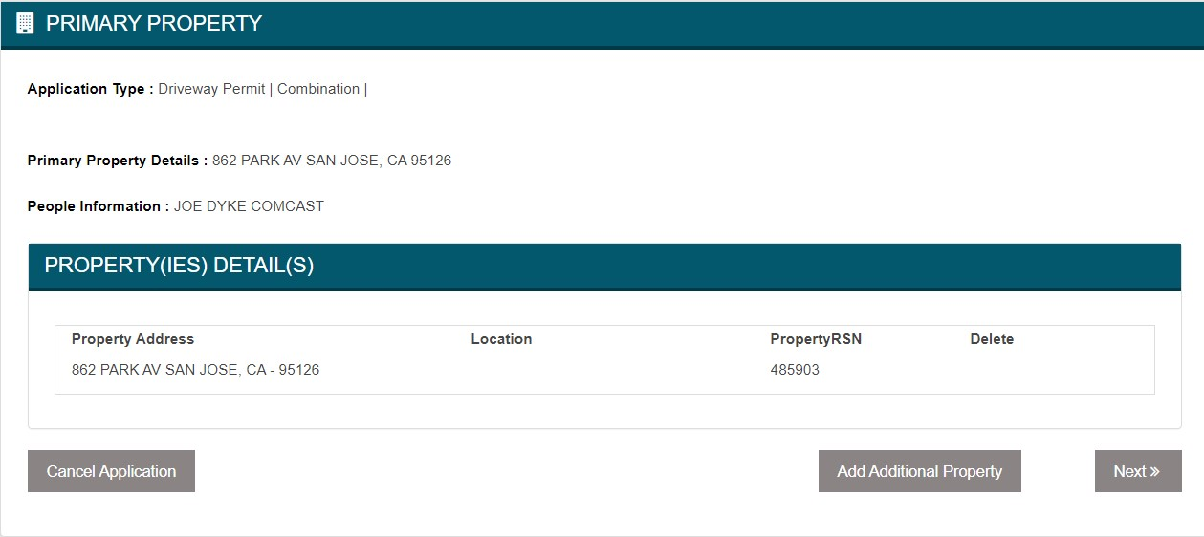

## Step 4.1 – Add Additional Properties (Optional)

Click on the “Add Additional Property” button and you will be presented with the same property search options as shown and discussed in Step 3. After you submit your search the results page differs from the Primary Property selection screen, with some exceptions. From this screen you will be able to:

1. Adjust the number of results shown on the screen
2. Filter through the results utilizing the “Search” box at the top right
3. Select the Property(ies) that pertain to your application from the search results. You will select the property(ies) by clicking on the check box in the “Select” column. Properties can be selected from any of the search result pages and they do not have to still be shown on the screen to be added to the permit. See the other guides and videos on adding properties for more information.
4. Add the Property(ies) to the application by clicking on the “Add Property(ies)” button
5. Click on the “Continue” button to return to the main “Additional Property Screen” without adding any properties.
6. Click on the “Return to Property Search” to perform a different search if the property(ies) you were looking are not present from your previous search.

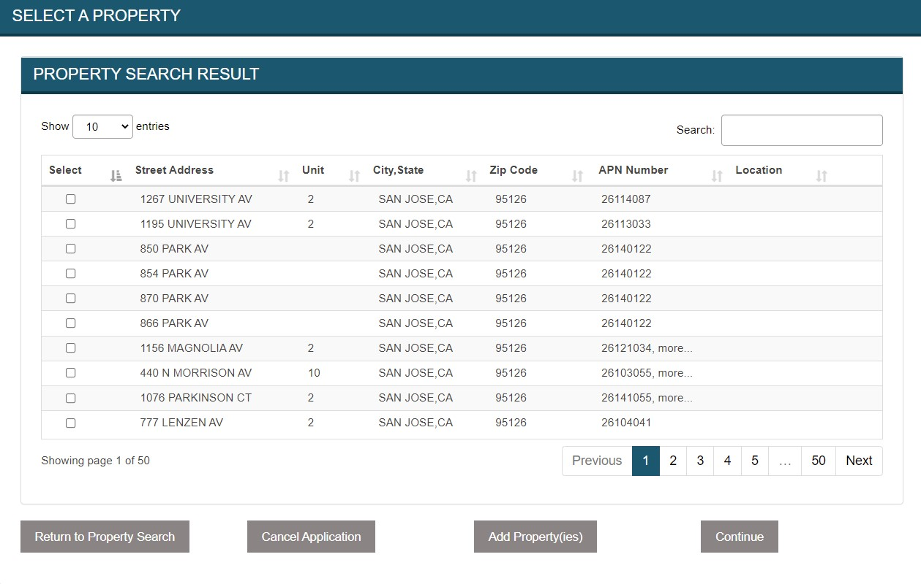

**6**

**3**

**5**

**4**

**2**

**1**

## Step 4.2 – Delete Properties from Application (Optional)

Once you have added the property(ies) to your application you will be redirected back to the Additional Property screen. The screen will now contain property(ies) you added to your application. You would have the ability to repeat the process if you needed to add more properties to your application. You can also delete any properties that were added by mistake, except for the Primary Property, by clicking on the “Delete” button next to the property.

# **Step 5 – Adding Project Collaborators**

After you have selected your primary property and any additional properties you will be taken to the Project Collaborators page. On this page you will see the people who have been identified as project collaborators. When you initiate the permit application there are set permit collaborators that get added to the application automatically and will vary on whether you use the “Apply on Behalf of” feature or not. Typically, the person who starts the application will see themselves as the Applicant and the property owner of the Primary Property will be added as the Owner in the application. If you selected a street segment or intersection as the primary property, then there will be no owner listed in the collaborators page.

From this page you can:

1. Add Additional Collaborators
2. Proceed to the next step
3. Cancel the Application
4. Return to My Services to Continue the Application Later
5. Graphical user interface, table

   Description automatically generatedGo back to the Properties page to add additional properties if you missed any

**5**

**4**

**3**

**2**

**1**

After you click on the “Add Collaborator” button you will have three options:

1. Add a new Collaborator to the application (See Step 5.1)
2. Add another Role to an existing Collaborator (See Step 5.2)
3. Go back to the Project Collaborators main screen

**1**

**2**

**3**

## Step 5.1 – Add New Collaborator (Optional)

To add a collaborator that does not currently exist in the application select the “Add New Collaborator” radio button to bring up the Collaborator Search screen. From the search screen you will have the options available to you to search for collaborators:

1. First Name
2. Last Name
3. Email address
4. Organization Name
5. Graphical user interface, application

   Description automatically generatedPeopleRSN

**3**

**2**

**4**

**5**

**1**

You may use as many of the options available to help narrow your search. However, if you are searching by PeopleRSN it is recommended that is the only field that is used. The searches allow for “wildcard” searches, so you don’t have to type in an exact match for your query. Refer to the help text on the page as well as the [Project Collaborator Guide](https://www.sanjoseca.gov/home/showdocument?id=86727) on how to do collaborator searches. Once you have your search criteria entered click the “Search” button to begin your search.

On the Collaborator search results screen you will be able to:

1. Adjust the number of results shown on the screen.
2. Filter through the results utilizing the “Search” box at the top right of the “Results” box.
3. Scroll through the results.
4. Select the Collaborator(s) you wish to add to your application by clicking the check box next t the name of the person you wish to add.
5. Select a Role for the Collaborator. **Note:** This dropdown will only appear next to selected collaborators. There can also only be one of each role for the application and roles available will vary per application type.
6. Add Collaborators to the application by clicking on the “Add Collaborator(s)” button. This will take you back to the Project Collaborators main screen with the collaborators you selected added to the application. **Note:** This button will only appear if you have selected at least one collaborator.
7. Go back to the Project Collaborators main screen by clicking on the “Previous” button without any additional collaborators.

**7**

**6**

**5**

**4**

**3**

**2**

**1**

## Step 5.2 – Add Additional Roles to an Existing Collaborator (Optional)

If you wish to add additional project roles for an existing collaborator select the “Add Additional Role to Existing Collaborator” radio button to bring up the “Current Collaborators” screen. From this screen you will be able to do the following:

1. Select the name of the existing collaborator you wish to add another role to from the “Name” dropdown.
2. Select the additional role you wish to assign the existing collaborator using the “Role” drop down. **Note:** There can only be one of each role for the application and roles available will vary per application type.
3. Add more collaborator roles by clicking on the plus (+) symbol located at the top right of the Current Collaborators screen
4. Delete any rows if you added a row by mistake by clicking on the trash can symbol next to the row you wish to remove.
5. Add the Collaborator(s) by clicking the “Add Collaborator(s)” button. This will take you back to the Project Collaborators main screen with the existing collaborators you selected added to the application with the roles you assigned. **Note:** This button will only appear if you have selected at least one existing collaborator.
6. Go back to the Project Collaborators main screen by clicking on the “Previous” button without any additional roles to the existing collaborators.

**6**

**5**

**3**

**4**

**1**

**2**

## Step 5.3 – Delete Collaborators (Optional)

If you have added any new collaborators and/or assigned additional roles to existing collaborators you will have the option to delete collaborators from the Project Collaborators main screen. To delete the collaborator from the application, click on the “Delete” button from the Project Collaborators main screen.

**Note:**

* Applicant and Owner roles cannot be deleted. If this needs to be modified contact the staff member who is assigned to your project for assistance.
* Users going through the application process, that are only listed once in the Project Collaborators screen, will not be able to delete themselves from their last role on the screen. This is because if you are not listed as a collaborator, you should not be able to modify an application.

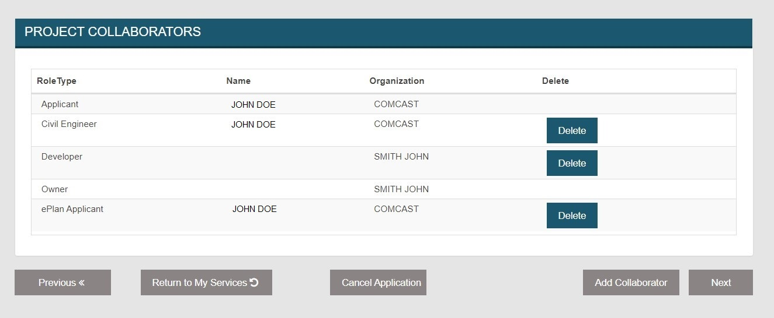

Once you click on the delete button a pop-up will display asking you to confirm the deletion. Click on “Ok” to proceed or “Cancel” to go back to the screen without deleting the collaborator.

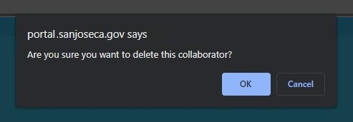

After the page reloads the deleted collaborator will no longer show in the list. You may repeat this process as many times as needed.

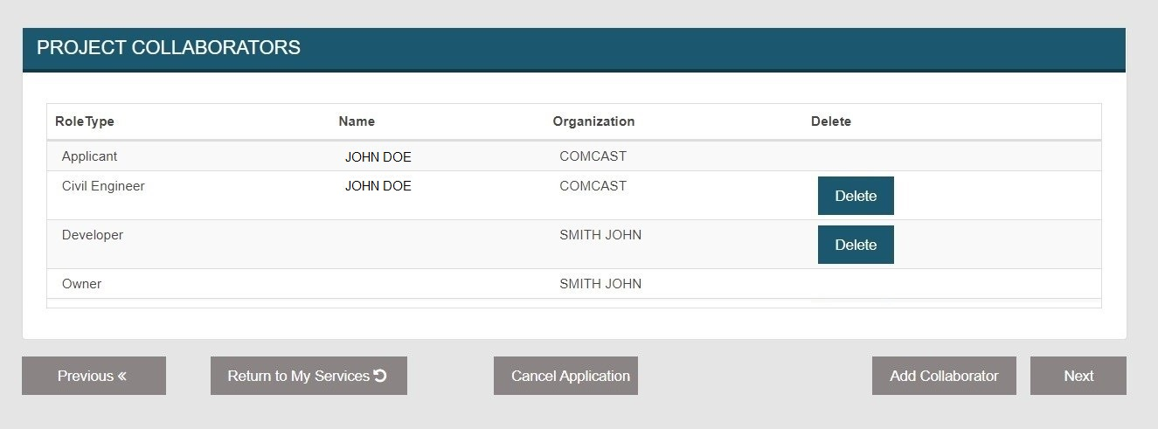

# **Step 6 – Adding Project Information**

You will be required to provide information specific to your application once you have added any additional collaborators to the application. The information required will vary depending on the Application Type, Application Sub and Work Type.

From this page you will input the Project Information displayed on the screen. Items indicated with a red asterisk next to the description of the requested information are required to be provided. If you do not have all the information at the time of the application you may pause the application to continue to application submittal later, as discussed in Index 1. From this page you may also go back to previous pages to provide additional information by clicking on the “Previous” button. After you have entered all required information you may proceed to the next section by clicking on the “Continue” button. You may also cancel the application by clicking on the “Cancel Application” button.

**Note:** If you attempt to continue without providing all required information an error message will display as shown below:

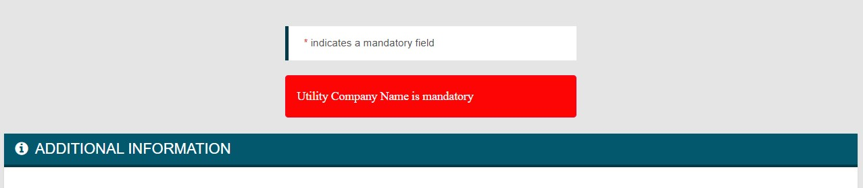

Some information that is not marked as required may become required if you answer a question in a certain way. In those cases, a message will display on the screen as shown below. You will need to address this issue prior to being able to proceed forward:

# **Step 7 – Upload Application Attachments**

If your application is not being initiated as an SJePlans electronic plan review project, you will be required to upload attachments as part of the permit application process. The required attachments are included in the applicable instructions document that you can access through the [Public Works Online Application Page](https://www.sanjoseca.gov/your-government/departments-offices/public-works/public-works-development-services-online-applications). Once the file has been uploaded you will see a list of the files below the “Upload Attachment” box where you will be able to download or delete the file if uploaded by mistake (See Step 7.1 on how to delete the attachments). On the Upload Attachments page, you will need to do the following:

1. **Select the Attachment Type** – The applicable attachment type will be indicated in the instructions. If you are uploading an item not indicated in the instructions choose the best attachment type that represents the document, you are attaching. Attachment types will vary depending on the Application Type you are submitting.
2. **Select the File to Attach** – You will need to click on the “Browse” button to find the file you wish to attach from your computer or network. There is no formal file naming convention, but the file should be appropriately named depending on the information being conveyed by the file. The allowed file types are: bmp, csv, doc, docx, gif, jpg, pdf, png, tiff, txt, vol, xls, xlsx.
3. **Add an Attachment Description** – You will be required to provide a description of the file you are attaching to help staff identify the attachments when reviewing them. The description is limited to 64 characters.
4. **Upload the Attachment** – Once you have done steps 1 through 3, you will need to click on the “Upload Attachment” button to upload the attachment. Repeats steps 1 through 3 until you have attached all attachments for the application.
5. **Complete Application Submittal** – Once you have uploaded all the attachments click on the “Next” button to complete your application submittal.

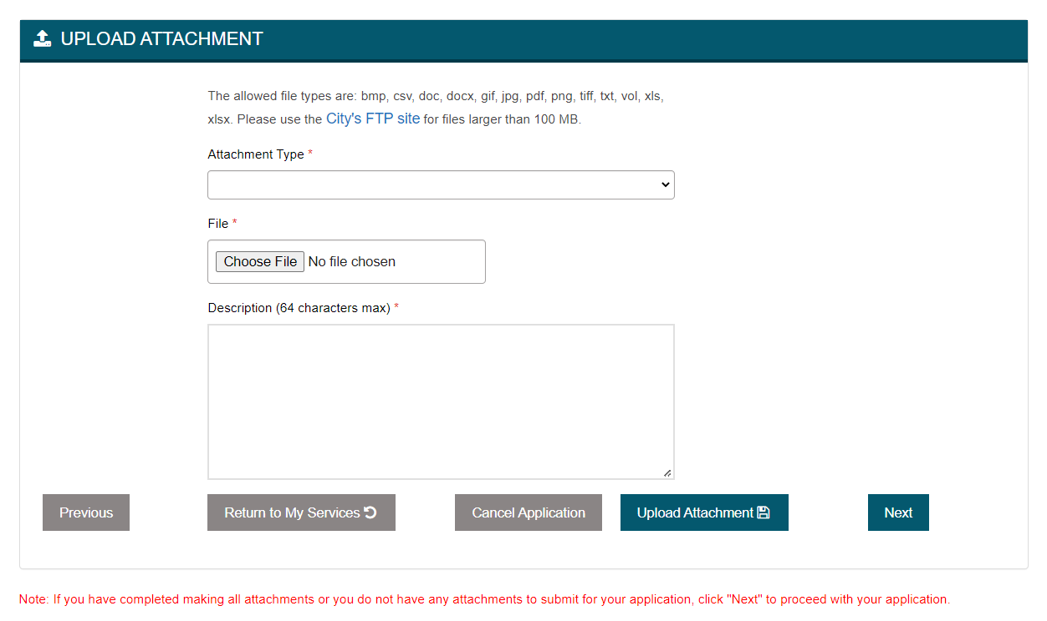

**5**

**4**

**1**

**2**

**3**

## Step 7.1 – Review and/or Delete Attachments (Optional)

Once you have uploaded at least one attachment, you will be able to see a list of the attachments that you have uploaded below the “Upload Attachment” box. Here you will be able to:

1. Review, the attachment type, attachment description and the attached files name.
2. Download the attachment for verification
3. Delete the attachment if you uploaded the attachment by mistake.

Attachments will only be available to be deleted on the initial submittal or up until Public Works staff have verified your uploaded attachment. Once the file has been verified you will no longer be able to delete the attachment. If you are unsure if the file should be deleted, you can download the file to view the contents prior to deleting it from the record by clicking on the “Download” button. If you wish to delete the file, click on the “Delete” button next to the attachment you wish to delete.

**3**

**2**

**1**

When you click on the delete button a pop-up window will display asking you to verify if you wish to delete the attachment. Click on “Ok” to proceed with the file deletion or “Cancel” to return to the “Upload Attachments” screen without deleting the attachment.

# **Step 8 – Application Submission Complete / Post Submission Page**

Congratulations, you have now officially completed your submittal! If you did not complete Steps 1 through 7, your submission **will not** be deemed complete. You must reach this step in order for the submission to be deemed complete, for staff to be assigned to the project to officially begin the review process. From this page you will be able to:

1. Return the My Services where you can, among other things, review previous applications, start new applications, or pay outstanding invoices.
2. Visit the Applications and Resources page of the Development group you have applied with by clicking the “Applications Resources Page” link.
3. Visit the SJePlan Resources page, if your permit is an SJePlans permitted project, by clicking the “SJePlans Resources Page” link. This page provides useful guides, videos, and documents to help you begin the electronic plan review process.

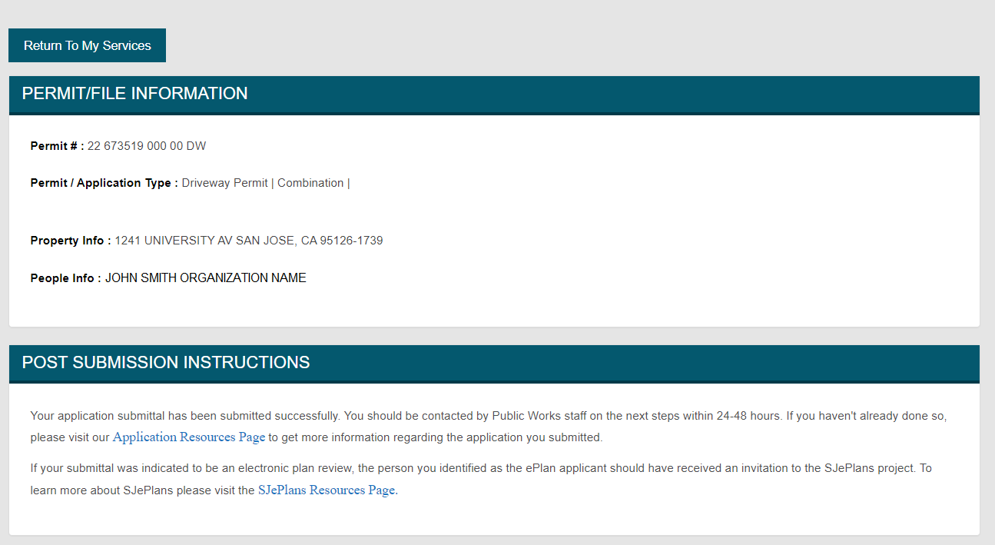

# **Index 1 – Pausing a Submittal Application**

Beginning at Step 4 and up until you complete Step 7, you may pause your application submittal and come back later to complete the application within sixty (60) calendar days of the initial submittal. If you pause an application and you do not come back to complete it within sixty (60) calendar days, your application will be cancelled or purged from the system. If the application is still needed, you would be required to begin the application process again. To pause the application, you have two options available to you.

**Option 1** –On the main application screen, you will be presented with the option of clicking on the “Return to My Services” button.

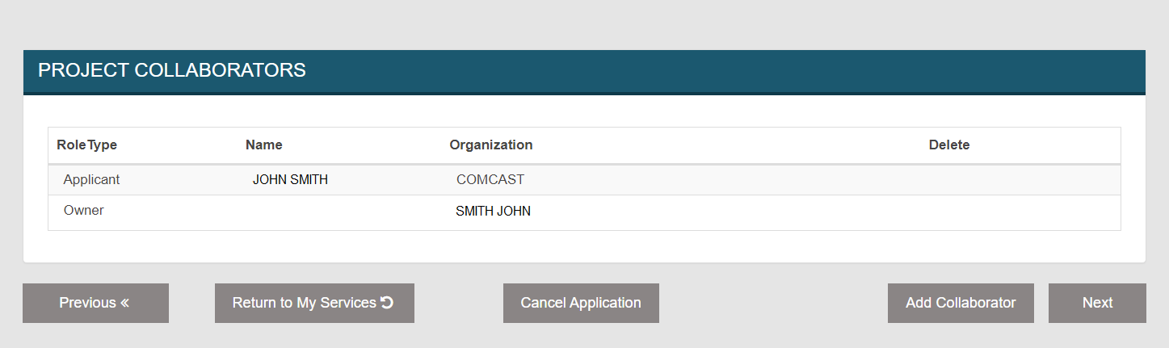

On the next screen you will have the following 2 options:

1. **Yes, Complete Application Later** – This will pause your application and you will be able to continue your application later. See Index 2 on Continuing an Application
2. **No, Return to My Application** – This will send you back to the application page you were previously on.

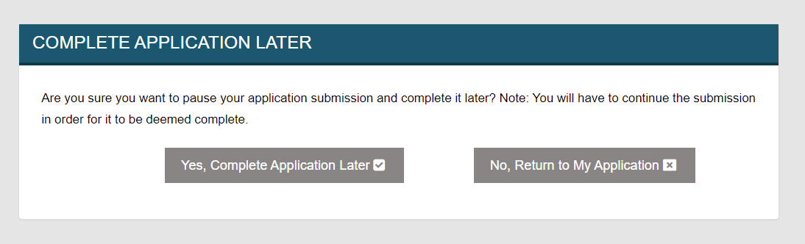

**1 2**

**Option 2** – At the top right of the of the screen, in the City of San Jose banner, there is a link that reads: “My Services.” Click on this link and it will take you back to the My Services home page and will pause the application process.

# **Index 2 – Continuing a Submittal Application**

If you paused the Application submittal or completed the submittal, and have new information you need to add, you will have the ability to “Continue to Submit” the application. To continue to submit the application you will need to find your application from the “Folder Details” section of the My Services homepage. **Note:** To continue to submit the application the “Application Status” shown on the My Service homepage must be “In-Progress.” Any other status will not allow you continue to submit your application.

From the My Services homepage find your project by either scrolling through the list, or by filtering the projects shown in the list by utilizing the “Search” bar at the top right of the “Folder Details”. All columns shown in the My Services page are used for the filtering. Once you have found your project, click on the “Detail” button next to the project you wish to continue to submit to be directed to the “My Service Details” page.

From the My Services Details page click on the “Continue to Submit Application” button at the top to begin. When you begin the continue to submit process, you will start at Step 4 and work through Step 8. I

**Note:** If you do not see the “Continue to Submit Application” button this means your Application Status is not “In-Progress.” Any updates to your application, other than uploading attachments (see Index 3), would need to be coordinated through your project contact(s). Also, **if you did not reach Step 8 on your initial submittal, you must reach Step 8 for your application to be deemed complete**, as discussed earlier.

# **Index 3 – Uploading Additional Attachments After Initial Submittal**

If the project is not initiated as an SJePlans project and either 1) Forgot to make attachments during the initial submittal; or 2) Staff have indicate that you need to provide additional attachments, then you will have two options to make the additional attachments.

**Option 1** – If your Application Status is listed as “In-Progress” you can utilize the “Continue to Submit” feature as identified in Index 2. Follow the steps from Index 2 and proceed through Steps 4 through 6, to land on the Upload Attachments page. Follow the steps described in Step 7 to upload the attachments.

**Option 2** – For this option, the “Status” of the application in the “Folder Details,” shown on the My Services homepage, must be “Under Review.” If the status is “Under Review” you will have the option to utilize the “Upload Attachment” feature from the “My Services Detail” page. From the My Services homepage follow the steps identified in Index 2 to navigate to the “My Application Detail” page of your application. If the status is shown as “Intake” please follow the continue to submit route identified in Index 2 to upload the additional documents.

On the My Service Details page you will see the “Upload Attachments” button. Click on this button to be taken to the Upload Attachment Page. **Note:** If you do not see the “Upload Attachments” button you’re your permit applications Status is not “Intake” or “Under Review.”

Uploading attachments, verifying attachments, or deleting attachments from the Upload Attachments page, follow the steps previously outlined in Step 7. Once you have finished uploading, reviewing, or deleting your attachments, click on the “Return to My Application Details” button to return to the My Application Details page.

