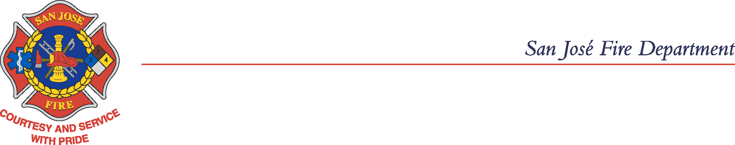
Office of the Fire Marshal

Rules and Laws Regarding Fireworks

The City of San Jose recognizes that celebrating this time of year has traditionally involved setting off fireworks. We do not want to detract in anyway from these celebrations, but we do want to request your cooperation in keeping the holiday safe. As your Fire Marshal, I am writing this letter to help clarify the laws that prohibit the use of fireworks at all times.

The State of California has outlawed most fireworks. State law allows for exceptions when the Fire Chief determines that it is okay to issue a permit. However, the City of San Jose has outlawed ALL fireworks. The City Municipal Code states:

“Except where otherwise expressly provided in this Code, it shall be unlawful for any person to possess, store, offer for sale, expose for sale, sell at retail,
or use or explode any fireworks.”
(SJMC 17.12.940)

The only acceptable use of fireworks is for a “pyrotechnic display,” operated by a Licensed Pyrotechnician, which requires a City Permit. The Fire Prevention Bureau issues permits for pyrotechnic displays, but only for fully professional displays under very strict safety regulations.

Other than that specific exception, ANY individual who possesses, stores, sells, or uses ANY fireworks is in violation of the law and subject to arrest. VIOLATION OF THESE LAWS CAN RESULT IN A FINE OF UP TO $1,000, AND POSSIBLY TIME IN JAIL.

These rules have been written in the interest of public safety. Fireworks cause hundreds of severe injuries in the United States every year, and cause thousands of fires in California every year.

The San Jose Fire Department, in coordination with the San Jose Police Department, respectfully request your cooperation in obeying the laws regarding fireworks, and helping us keep San Jose the Safest Big City in America.

